MS Word Worksheet -4-
Session 10 (181-193)

In the same previous word document (sheet 3) do the following:
- Insert a picture from online pictures :

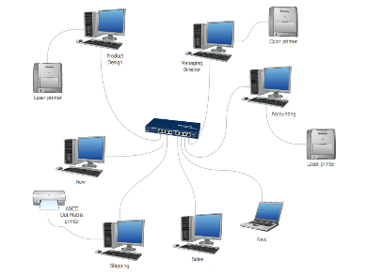
Computer Network
A Computer Network is a communication system that connect two or more computers so they can exchange information and share resources.
The most well-known computer network is the Internet

- Change the text wrapping around the picture to tight.
- Crop the picture.
- Apply an artistic effect to the picture.
- Try to change the picture position using the position command.
- Insert a shape in page 3 and write (network benefits) inside it.
- Format your shape using the new contextual format tab
- Try to resize it using the high & width boxes in the size group.
- In page 2 insert smart art as below:

- Change the SmartArt color.
- Add bookmark to page2 ,delete it.
- Write :" for more information " and add link to it , see the different types of hyperlink
- Add header for the pages contain the date and "computer network"
- Add footer for the pages contain the page number

