MS Word
Worksheet -1-
Session 7 (139-154 without p 145)
- User inter face
- Quick access toolbar
- Ribbon
- Tabs
  - Groups
    - Dialog box launcher
- Work area
- Ruler
- The status bar
- View buttons
- Zoom slider and buttons
- Adding commands to quick access toolbar
- Removing commands from quick access toolbar
- Ribbon display option
- Using access keys
- Create a new document
- Entering text
  - Enter key
  - Tab key
(look at keyboard sheet)
- Type this text :
The Computer system
Computer is an electronic device, that can accept data (input), manipulate data (process), and produce information (output) and store it, and it is operating under the control of instructions (software).

الحاسب الالي
هو آلة الكترونية تستقبل بيانات ثم تقوم بإجراء عملية تحليل ومعالجة عليها و إخراج المعلومات أو تخزينها وتعمل بناء على تعليمات دقيقة تسمى برنامج
- Selecting text : Mouse, Keyboard
- Deleting text
- Undo & redo
- Navigating through a document:
  - Keyboard
  - Mouse
- The file tab
  - Saving a document
  - Saving as
  - Closing a document
  - Opening a document
  - Pinning a recent document
  - Printing a document
- Home tab:
  - Clipboard group :
    - Cut ,copy, paste
  - 3 other ways for Cut ,Copy, Paste
  - Clipboard pane

MS Word
Worksheet -2-
Session 8 (155-166)

- In the previous text apply these format to the title:
  - Font: verdana
  - Font size: 14
  - Font color: blue
  - Font style : bold, italic, underline

- Try to increase and decrease font size
- Change the title case to uppercase

- Highlight the title in yellow

- Apply a text effect to the Arabic title :change the outline color and try the other effects : shadow, reflection …
- Type this text before the Arabic paragraph :
- Computer hardware :
  - CPU
  - MEMORY
    - RAM
    - ROM
  - Input devices
  - Output devices
  - Storage drives

CPU speed measured in hertz (Hz)
KHz = 1000 HZ
MHz= 1000000 Hz
GHz=1000000000 Hz
RAM capacity measured in byte
- Strikethrough “KHz = 1000 HZ”

- Type this text :
KB =2¹⁰ =1024 byte
- Try to use Font dialog box

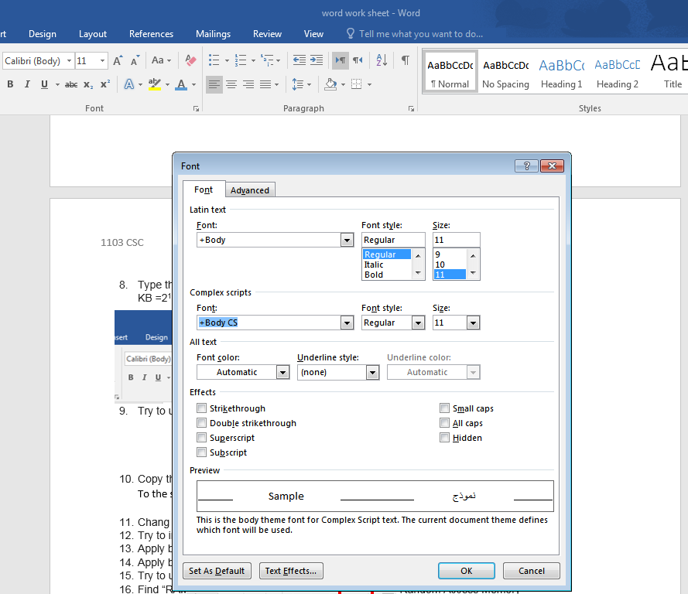

- Copy the formatting style of the main title “The Computer system”
To the subtitles “CPU” & “RAM”
- Chang the alignment of the title to center

- Try to increase & decrease the indent of the English paragraph

- Apply bullets & numbering as shown

- Apply border and shading to the first paragraph

- Try to use paragraph setting dialog box
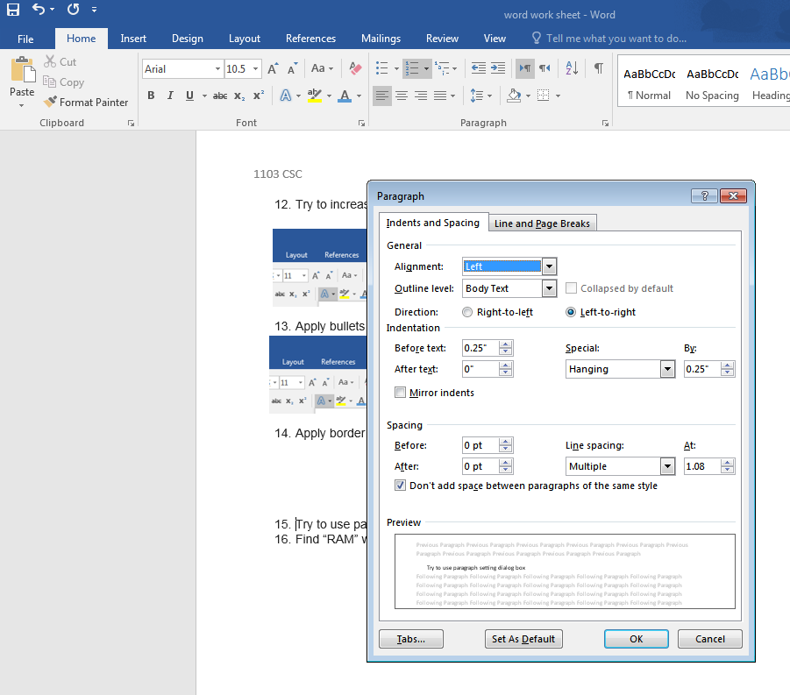

- Find “RAM” word in the document and replace it with “Random Access Memory”

Final form of the document :-

MS Word
Worksheet -3-
Session 9 (167-178)

- In new word document writ the following text:

Computer Network
- A Computer Network is a communication system that connect two or more computers so they can exchange information and share resources.
The most well-known computer network is the Internet

- apply these format to the title:
  - Font: times new roman
  - Font size: 14
  - Font style : bold, underline
  - Alignment : center
- In new page(use page break) insert the following table :

Types of Computer Networks
According to:
Transport Media | Wired and Wireless
Management System | Peer to Peer, Client – Server

- Format the table as shown (border-shading-merge & split cells-text alignment)
- Split the cell containing “Wired and Wireless” to be :
Transport Media | Wired | Wireless

- Insert a new row after the third row contain the following:
Geographical Area (PAN, LAN, MAN and WAN)
- Try to delete this row
- Insert a new page between the first and second page (use blank page) and write the following :
Benefits of Computer Networks:
- Exchanging Information
- Sharing of resources:
    - Software
    - Hardware
- Insert a cover page for the document and write a title and your name on it.

