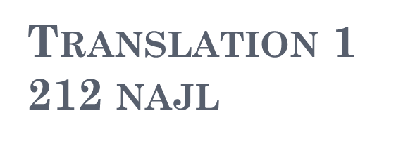

Material used:
- Different new passages are distributed by instructor every meeting.
Resources:
- TRANSLATION AS PROBLEMS AND SOLUTIONS
\ PRFESSOR HASAN GHAZALA
اسس الترجمة من الانجليزية الى العربية والعكس
د. عز الدين محمد نجيب
فن الترجمة للطلاب والمبتدئين
أكرم مؤمن

Distribution of Marks:
- 10 pts. On classwork :
(5 on assignments and participation)+(5 on blackboard participation)
- 25 pts. 1st in-term
- 25 pts. 2nd in-term
- 40pts. Final

What is translation?

Oxford dictionary
- The process of changing something that is written or spoken into another language.

- It generally refers to all the processes and methods used to render and\or transfer the meaning of the source language( SL) text into the target language (TL) as closely , completely and accurately as possible.

What do we translate?
- We translate neither grammar, words, style nor sound.
- We only translate one thing only :
Meaning

How do we translate?
TRANSLATION STEPS:

- First reading .Skim the ST(source text) to get a general idea about the topic.
- Second reading .Do a second comprehensive reading to fully understand the ST.
- Third reading . locate the difficult words ,terms or phrases. Then look up their meanings in a dictionary.
- Fourth reading. Read each sentence , then translate it literally into the TT(target text).
- Fifth reading. Reread each sentence to restructure it according to the target language style.
- Sixth reading. Read the whole TT , to link between the sentences.
- Seventh reading. A final reading to revise the TT ,to correct the spelling, grammatical and stylistic mistakes.

TRANSLATION TOOLS
DICTIONARIES

Language
1-Monolingual dictionaries.
- English\English
The oxford English dictionary
- Arabic \ Arabic
المعجم الوسيط
مختار الصحاح
- 2- Bilingual Dictionaries.
- English \ Arabic
المورد الكبير
Arabic \ English
معجم اللغة العربية المعاصرة (هانز فير)

Type

1- General Dictionaries.
2- Specialized Dictionaries.
- Technical scientific terms.
- Religious terms.
- Banking and financial terms.
- Tourism and Hotels.

Form

1-Printed Form.
2- Electronic Dictionaries
Atlas dictionary.
3- Dictionaries for Natural Language Processing
; Machine translation.
4- On-line Dictionaries.
Google.

