Consider Figure 2-3 as another example. Using a class C network of 192.168.10.0/24 design a VLSM solution to accommodate host requirements of all the segments.
Figure 2-3 VLSM – Example #2
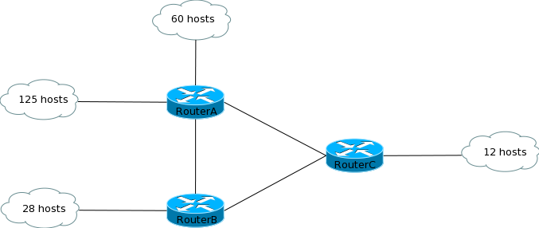
To design the VLSM solution, follow the 5 steps discussed earlier:
- The largest segment requires 125 host addresses. So a mask of /25 can be used. This gives two subnets – 192.166.10.0/25 and 192.168.10.128/25. The first subnet can be assigned to this segment.
- The second largest segment requires 60 host addresses. You can take the second available subnet – 192.168.10.128/25 – and divide it further using a /26 mask to give you subnets 192.168.10.128/26 and 192.168.10.192/26. Assign the first one to this segment.
- The third largest segment requires 29 host addresses (28 host addresses and 1 for the router interface). You will need to use a block of 32 and a mask of /27. Take the remaining subnet from the previous step and divide it further using a /27 mask. This will give you subnets 192.168.1.192/27 and 192.168.1.224/27. Assign the first one to this segment.
- The fourth largest block requires 13 host addresses (add one for the router interface). You can use a block of 16 and a mask of /28. Take the remaining subnet from the previous step and divide it further using a mask of /28. This will give you subnets 192.168.1.224/28 and 192.168.1.240/28. Assign the first one to this segment.
- Now you are left with 3 point-to-point links between the routers. These links require two host addresses and a mask of /30. Take the remaining subnet from the previous step and divide it using a mask of /30. This will give you subnets 192.168.1.240/30, 192.168.1.244/30, 192.168.1.248/30 and 192.168.1.252/30. Use the first three of these for the point-to-point links. The remaining one subnet can be left for future use.
Figure 2-4 shows the solution derived in the above steps.
Figure 2-4 VLSM – Solution for Example #2
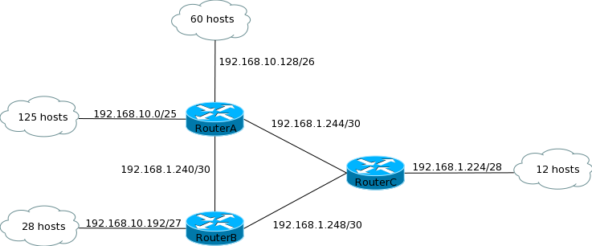

Source:
http://www.freeccnastudyguide.com/study-guides/ccna/ch2/vlsm/

