Exercise 3
Your address space is 192.168.6.0/23. The number of hosts needed for each LAN is shown in Figure 9-6. Use VLSM to create a contiguous IP addressing scheme. Label Figure 9-6 with your addressing scheme. Don’t forget the WAN links.
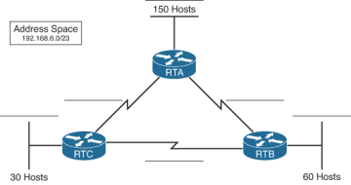
Figure 9-6 Addressing Design Exercise 3 Topology
List the address space that is still available for future expansion.

Exercise 4
Your address space is 10.10.96.0/21. The number of hosts needed for each LAN is shown in Figure 9-7. Use VLSM to create a contiguous IP addressing scheme. Label Figure 9-7with your addressing scheme. Don’t forget the WAN links.
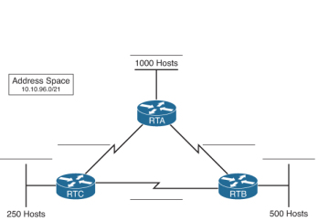
Figure 9-7 Addressing Design Exercise 4 Topology

