1- Task One
public static int fact(intnum) {
if (num == 0) // base case
return 1;
else // recursive case
return num * fact(num – 1);
}

Trace fact(5);
Show how the execution works in detailed steps, tracing :
- Each time there is a call to function fact()
- And when the function returns how are the values affecting the final result.

2- Task Two

Write a recursive function that prints the numbers 1...n
in descending order (big value first):

- What would be the small change on the code to make it prints in ascending order?

public void descending(int n)

3- Task three
Write a recursive function convert a decimal number into a binary number, printing the binary number

public static void decToBin(int num)

Solutions:

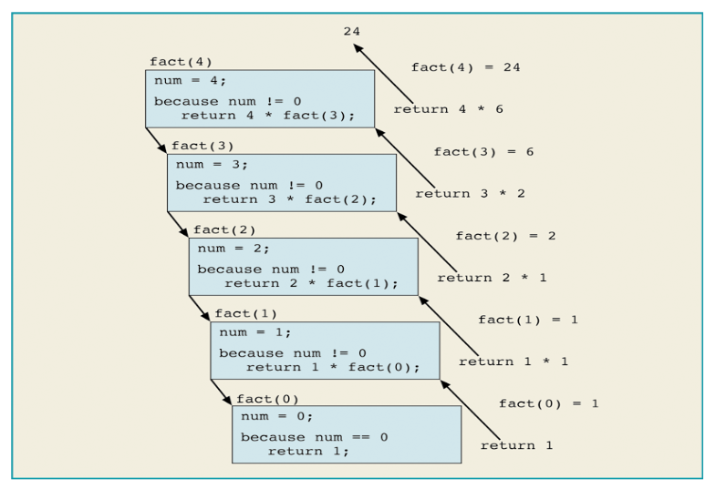

public void descending(int n) {
if (n <= 0)
return;
System.out.println(n); // switch lines to make it asc
descending(n-1); // …
}

public static void decToBin(int num)
{
if(num > 0)
{
decToBin(num / 2);
System.out.print(num % 2);
}
}

