Tutorial # 4
Question#1: What is the output of the following programs?
- 1 For row = 1 To 10
2 For star = 1 To 10 - row
3 outputTextBox.AppendText("*")
4 Next star
5 outputTextBox.AppendText(vbCrLf)
6 Next row

outputTextBox
What will be displayed here?

- 1 Dim y As Integer
2 Dim x As Integer
3 Dim mysteryValue As Integer
4
5 x = 1
6 mysteryValue = 0
7
8 Do
9 y = x ^ 2
10 displayListBox.Items.Add(y)
11 mysteryValue += 1
12 x += 1
13 Loop While x <= 10
14
15 resultLabel.Text = mysteryValue

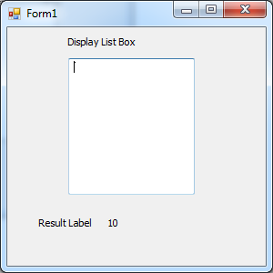
What will be displayed here?

- 1 Dim power As Integer = 5
2 Dim number As Integer = 10
3 Dim result As Integer = number
4
5 For i As Integer = 1 To (power - 1)
6 result *= number
7 Next
Trace the values of the following variables throughout the loop:
i | result

Question#2: What is wrong with the following codes?
- 1 Dim y As Integer = 5
2 Dim z As Integer = 10
3 Do
4 z *= y
5 Loop While y >= 1
6 y -= 1
7 resultLabel.Text = z
Line# | Error Description | Error Type (Syntax or Runtime) | Correction

- 1 Dim num As Integer = 5
2
3 For i As Integer = 100 To (num ^ 2) step 2
4 result *= num
5 Next
6 i = i ^ num
Line# | Error Description | Error Type (Syntax or Runtime) | Correction

