Q1: Write a program that
- calculates the sum of the even elements of the array below.
s[]={ 1,2,4,5,6,2,9,4,10,1};

- assume you have two arrays
array1 [5] = {1, 2, 3, 4, 5}, array2 [5] = {10, 9, 8, 7, 6}
- Multiply two arrays array 1 and array2 and store the result in a third array3 .
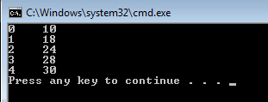

- Display the values in array3 in reverse order .
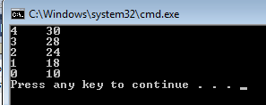

- Find the value 24 in array3 and show the index of the matching array element.
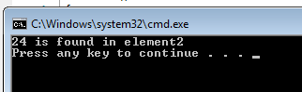

Q2. What would be output by the following section of C++?
int A[3] = {1 , 2, 3} ,i;
for (i=0; i<=2; i++)
{
A[i] = A[i]*A[i];
cout << A[i] << " ";
}

Q3. What is wrong with the following section of program?
int A[10], i;
for (i=1; i<=10; i++)
cin >> A[i];

