KING SAUD UNIVERSITY
College of Applied Studies and Community Service
Applied Computing
tutorial

Given the following diagram, Implement all the Classes and write a client code to test your application.

Emlpoyee
+ name
+Ssn
+CalculateEarning()
SalariedEmployee
-weeklySalaryValue
+CalculateEarning()
CommissionEmployee
-grossSales value
-commisionRateValue
+CalculateEarning()

- Class Employee:
CalculateEarning(): return double and its must override method.
- Class Salaried Employee:
CalculateEarning(): return the weekly salary employee
- Class Commission Employee:
CalculateEarning(): return the commission rate multiply by gross sales values.
- Write appropriate properties for each class.
- The client program should be test the application by creating 1 Salaried employee object and display his salary. In addition to create 1 commission employee object and display his salary.

Question 2:

Write a program that will read information from MyList.txt file then create MyReceipt.txtfile. Suppose that a file MyList.txt contains the following data.

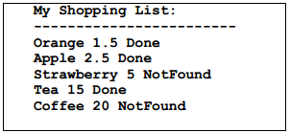

And as result MyReceipt.txtfile will be:
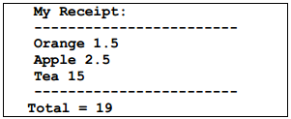

In MyList.txt, second line represent item name, item price, and if it is available in the store or not, respectively.

