- Write a C++ program that asks the user to enter 2 numbers then displays a menu on the screen as shown below:
A. Print sum
B. Print average
C. Print sum and average
The program reads the user’s option and then display the result. Your code should recognize the invalid characters and display "invalid choice!!" message.
(use switch)
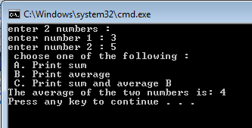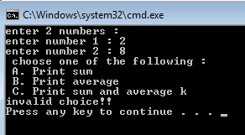
- If inputChar is a variable of type char, use the switch statement below to answer questions:
switch (inputChar) {
case 'A':
case 'a':
cout<<inputChar<<endl;
case 'Z':
case 'z':
cout<<inputChar<<endl;
break;
default:
cout<<inputChar<<“ is not found”<<endl;
break;
}
- What is the output when inputChar is 'A'?
- What is the output when inputChar is 'B'?

- ask the user to enter an integer from 1-12 and displays equivalent month. If the user enters an invalid number, print an error message.

