KING SAUD UNIVERSITY
COLLEGE OF APPLIED STUDIES AND COMMUNITY SERVICE
CSC 1101
Tutorial (2)

Q1. Where possible, write equivalents for the following equations using C++ statements:
1. $3a+4yx-6$

Q2. Suppose a, b, sum are integer variables and c is a double variable; and a=3 and b=5 and c=14.1. What value is assigned to each variable after each statement executes?

1. sum = a+(int)c* 2 ;
2. sum=a*++b/2;
3. sum= b%3+ (int)c;
Q3. State the order of evaluation of the operators in each of the following C++ statements and show the value of x after each statement is performed
- x = 3 * 9 * 3 + 9 * 3 / ( 1+2 ) ;
- x = 3 * 9 * 3 + 9 * 3 / 1+2;

Q4. what is the output of the following c++ code lines:

#include <iostream>
using namespace std;

int main() {
int n1,n2;
float average;
cout<<"Enter first number";
cin>>n1; //assume the user entered 10
cout<<"Enter second number";
cin>>n2; //assume the user entered 13
average=(n1 + n2)/2;
cout<<"the average grade is "<< average <<endl;
return 0;
}

Q5. Where possible, write equivalents for the following statements using compound assignment operators:
- r = r / 10;
Q6. Assume the following:
int j = 6; int k = 10; int n; bool b = false;
Give the value that is assigned, or illegal.
- ______ n = k++;
- ______ n = (k++);
- __ ___ n = ++k;
- __ ___ n = 7++;
- ______ n = k++ + ++j;
Q7.
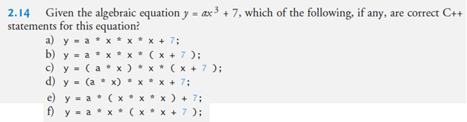

Important Note:
