KING SAUD UNIVERSITY
COLLEGE OF APPLIED STUDIES AND COMMUNITY SERVICE
CSC 1101 Second Semester 1436-1437
Tut # 2

Q1) Write a single C++ statement to accomplish each of the following
- Print the message "This is a C++ program" on one line.
- Print the message " This is a C++ program " on two lines. End the first line with C++.
- Print the message " This is a C++ program " with each word on a separate line.
- Print the message " This is a C++ program ". Separate each word from the next by a tab.
- Print the message to prompt the user to enter an integer. End your prompting message with a colon (:) followed by a space and leave the cursor positioned after the space.
- Declare the variables c, thisIsAVariable, q76354 and number to be of type int. (in single statement and in separate statements).
- Declare and initialize two variables, one int (named int_var ) and one double( named dub_var)? Both should be initialized to the appropriate form of 5.
- Declare any constant of type int.
- Compute the product of the three integers contained in variables x, y and z, and assign the result to the variable result.
Q2) Give good variable names for identifiers to store:
-The speed of an automobile?
-An hourly pay rate?
-The highest score on an exam?
Q3) Which of the following identifiers are valid , invalid and why?
- Student name | - G
- 1course | - #var
- course*name | - this_is_along_one
- main | - XyF 123
- float | - num#2

Q4) Show the output displayed by the following lines .
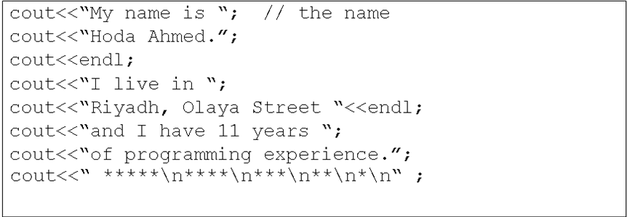
Q5) Write 2 separate programs that show the following:
1.) Hello\\ World'
2.) Hello,
World!
Q6) Write a program that draws a simple triangle of stars on screen using.
- One output statement
- Multiple output statements

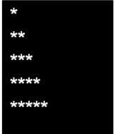
Q7) Write a C++ input statement that reads three integer values into the variables var1, var2, and var3, in that order.

Q8) Write a C++ output statement that prints the following, If we assume the age is an integer variable to contain the value 24 and the zipcode an integer variable to contain 90064.
int age = 24 , zipcode =90064;
Hello, I am 24 years old and my zipcode is 90064
Q10) What is the output for the following program? (Where i = 702)
#include <iostream>
using namespace std;
int main ()
{
int i;
cout << "Please enter an integer value: ";
cin >> i;
cout << "The value you entered is " << i;
cout << " and its double is " << i*2 << ".\n";
return 0;
}
.

Example:
4)
int a = 20;
int b = 10;
int c = 15;
int d = 5;
int e;

e = (a + b) * c / d; // ( 30 * 15 ) / 5
cout << "Value of (a + b) * c / d is :" << e << endl ;

e = ((a + b) * c) / d; // (30 * 15 ) / 5
cout << "Value of ((a + b) * c) / d is :" << e << endl ;

e = (a + b) * (c / d); // (30) * (15/5)
cout << "Value of (a + b) * (c / d) is :" << e << endl ;

e = a + (b * c) / d; // 20 + (150/5)
cout << "Value of a + (b * c) / d is :" << e << endl ;

return 0;
}
When the above code is compiled and executed, it produces the following result:
Value of (a + b) * c / d is :90
Value of ((a + b) * c) / d is :90
Value of (a + b) * (c / d) is :90
Value of a + (b * c) / d is :50

