

**Tutorial#5**

**Question#1:**What istheoutputof thefollowingprograms?

PrivateSubbtnDisplay_Click(...)HandlesbtnDisplay.Click

DimfirstNameAs String=""

DimlastNameAsString=""

Dimsalary,newSalaryAsDouble salary=0

textBox1.Text="FirstName:"& firstName&"LastName:"& lastName&" Salary="&salary

InputData(firstName,lastName,salary)

textBox3.Text="FirstName:"& firstName&"LastName:"& lastName&" Salary="&salary

newSalary= RaisedSalary(salary)

textBox5.Text="salary="&salary& ",NewSalary="& newSalary

EndSub

SubInputData(ByReffirstNameAsString,ByVallastNameAsString,ByRefsalaryAsDouble)

firstName= txtFirstName.Text

lastName=txtLastName.Text

salary=CDbl(txtCurrentSalary.Text)

textBox2.Text="FirstName:"&firstName&"LastName:"&lastName&"Salary="& salary

EndSub

FunctionRaisedSalary(ByValsalaryAsDouble)AsDouble

Ifsalary<=40000Then salary=1.05*salary Else

salary=salary+2000+ 0.02*(salary - 40000) EndIf

textBox4.Text="salary="&salary

Returnsalary

EndFunction

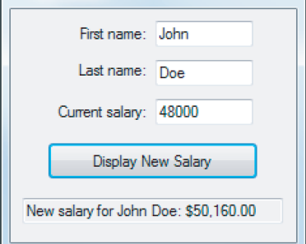

**Input:**

30000

|  |  |
| --- | --- |
| **textBox1.Text** |  |
| **textBox2.Text** |  |
| **textBox3.Text** |  |
| **textBox4.Text** |  |
| **textBox5.Text** |  |

**Question#2:Extract errorsfrom the following codes& thenobtainweatherthey are Syntax**

**ErrororRuntime Error?**

**a)**

1 PrivateSubCalculateArea(ByvalLengthAsDouble)AsDouble

2 ReturnLength^2

3 EndSub

|  |  |  |  |
| --- | --- | --- | --- |
| **Line#** | **ErrorDescription** | **ErrorType (Syntaxor Runtime)** | **Correction** |
|  |  |  |  |

**b)**

1 PrivateSubbtnCalculate_Click(...)HandlesbtnCalculate.Click

2

3 DimweightAsString= txtWeight.Text

4 DimheightAsString=txtHeight.Text

5 DimresultAsDouble

6

7result=BMI(weight,height)

8 EndSub

9

10FunctionBMI(ByValwAsDouble,ByValhAsDouble)AsDouble

11DimrAsString

12

14r= "Theresultequalsto"& ((703*w)/ (h^2))

15Returnr

16EndFunction

|  |  |  |  |
| --- | --- | --- | --- |
| **Line#** | **ErrorDescription** | **ErrorType (Syntaxor Runtime)** | **Correction** |
|  |  |  |  |
|  |  |  |  |
|  |  |  |  |



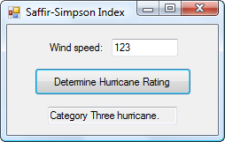

**Question#3:Convertthefollowingprogramintothreeprocedures(functionsorsubroutine) (one forreading input–twofor processing input–three for displaying output)**

Original Code

PrivateSubbtnDetermine_Click(...) HandlesbtnDetermine.Click

DimspeedAsDouble=txtSpeed.Text

DimoutTextAsString=Nothing

Ifspeed<74Then

outText="Notahurricane." ElseIfspeed<=95 Then

outText="CategoryOnehurricane."

ElseIfspeed<=110Then

outText="CategoryTwohurricane." ElseIfspeed<=130Then

outText="CategoryThreehurricane."

ElseIfspeed<=155Then

outText="CategoryFourhurricane." Else

outText="CategoryFivehurricane." EndIf

txtOutcome.Text= outText

EndSub

Codeafterbreaking itto procedures: