**Tutorial # 4**

**Question#1:** Trace the following code

**(a)**

Input 1 Input 2

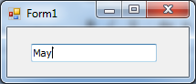 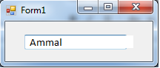

Dim word As String = TextBox1.Text

Dim firstLetter, secondLetter As String

Dim flag As Boolean = True

For i As Integer = 0 To word.Length - 2

firstLetter = word.Substring(i, 1)

secondLetter = word.Substring(i + 1, 1)

If firstLetter = secondLetter Then

txtOutput.Text = "Equal letters, first = second letter = " & firstLetter

Exit For

End If

If i = word.Length - 2 Then

txtOutput.Text = "This word has no repeated letters" End If

Next

Trace of Input 1

|  |  |  |  |
| --- | --- | --- | --- |
| i | firstLetter | secondLetter | txtOutput.Text |
|  |  |  |  |
|  |  |  |  |
|  |  |  |  |
|  |  |  |  |

Trace of Input 2

|  |  |  |  |
| --- | --- | --- | --- |
| i | firstLetter | secondLetter | txtOutput.Text |
|  |  |  |  |
|  |  |  |  |
|  |  |  |  |
|  |  |  |  |
|  |  |  |  |
|  |  |  |  |



**Question#2:** What is the output of the following?

**(a)**



Dim number, R, L As String, position As Integer

number = "123.4567"

position = InStr(number, ".")

TextBox1.Text= position

L = number.Substring(0, position)

R = number.Substring(position, number.Length - position)

TextBox2.Text = L

TextBox1.Text = R

txtLeft.Text =...................., txtRight.Text= ……………………………………

**(c)**

Input1 Input2

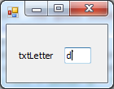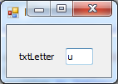

Dim sentence = "THE QUICK BROWN FOX JUMPS OVER A LAZY CAT" Dim letter As String

Dim position As Integer

letter = txtLetter.Text.ToUpper position = sentence.IndexOf(letter)

txtOutput.Text = letter & " first occurs in position " & position & "."

|  |  |
| --- | --- |
| txtLetter.Text | txtOutput.Text |
| u |  |
| d |  |