COLLEGE OF APPLIED STUDIES AND COMMUNITY SERVICE

CSC 1201 second Semester 1437-1438

Tut 1

___________________________________________________________________________________

1) Write a function called significant-digit that reads an integer number then print the least significant digit and the next least significant digit.

Example:
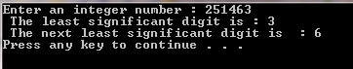

2) Write function that calculate the Fahrenheit according to the following equation
Fahrenheit = Celsius + 32
Example:
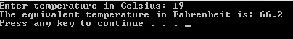

3) Suppose that you have the following inputs: 4 6 1000 0.
What is the output of the following code?

#include <iostream>
using namespace std;

void odd (int x);
void even (int x);

int main()
{
int i;
do {
cout << "Please, enter number (0 to exit): ";
cin >> i;
odd (i);
} while (i!=0);
return 0;
}

void odd (int x)
{
if ((x%2)!=0) cout << "It is odd.\n";
else even (x);
}

void even (int x)
{
if ((x%2)==0) cout << "It is even.\n";
else odd (x);
}

