58Turbulent Flows
- The turbulent motion is an irregular motion.
- Turbulent fluid motion can be considered as an irregular condition of flow in which various quantities (such as velocity components and pressure) show a random variation with time and space in such a way that the statistical average of those quantities can be quantitatively expressed.
- It is postulated that the fluctuations inherently come from disturbances (such as roughness of a solid surface) and they may be either dampened out due to viscous damping or may grow by drawing energy from the free stream.
- At a Reynolds number less than the critical, the kinetic energy of flow is not enough to sustain the random fluctuations against the viscous damping and in such cases laminar flow continues to exist.
- At somewhat higher Reynolds number than the critical Reynolds number, the kinetic energy of flow supports the growth of fluctuations and transition to turbulence takes place.
Characteristics of Turbulent Flow
- The most important characteristic of turbulent motion is the fact that velocity and pressure at a point fluctuate with time in a random manner.
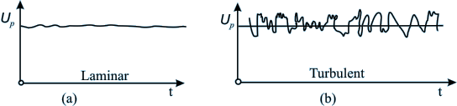
Fig. 1 Variation of horizontal components of velocity for laminar and turbulent flows at a point P
- The mixing in turbulent flow is more due to these fluctuations. As a result we can see more uniform velocity distributions in turbulent pipe flows as compared to the laminar flows.
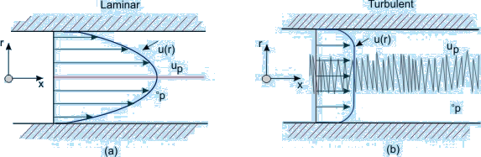
Fig. 2 Comparison of velocity profiles in a pipe for (a) laminar and (b) turbulent flows
Turbulence can be generated by -
Frictional forces at the confining solid walls
Flow of layers of fluids with different velocities over one another
The turbulence generated in these two ways are considered to be different.
Turbulence generated and continuously affected by fixed walls is designated as wall turbulence, and turbulence generated by two adjacent layers of fluid in absence of walls is termed as free turbulence. One of the effects of viscosity on turbulence is to make the flow more homogeneous and less dependent on direction.
- Turbulence can be categorized as below -
- Homogeneous Turbulence: Turbulence has the same structure quantitatively in all parts of the flow field.
- Isotropic Turbulence: The statistical features have no directional preference and perfect disorder persists.
- Anisotropic Turbulence: The statistical features have directional preference and the mean velocity has a gradient.
Homogeneous Turbulence: The term homogeneous turbulence implies that the velocity fluctuations in the system are random but the average turbulent characteristics are independent of the position in the fluid, i.e., invariant to axis translation.
Consider the root mean square velocity fluctuations
, ,
In homogeneous turbulence, the rms values of u', v' and w' can all be different, but each value must be constant over the entire turbulent field. Note that even if the rms fluctuation of any component, say u' s are constant over the entire field the instantaneous values of u necessarily differ from point to point at any instant.
Isotropic Turbulence: The velocity fluctuations are independent of the axis of reference, i.e. invariant to axis rotation and reflection. Isotropic turbulence is by its definition always homogeneous. In such a situation, the gradient of the mean velocity does not exist, the mean velocity is either zero or constant throughout.
In isotropic turbulence fluctuations are independent of the direction of reference and
= = or
It is re-emphasized that even if the rms fluctuations at any point are same, their instantaneous values necessarily differ from each other at any instant.
Turbulent flow is diffusive and dissipative. In general, turbulence brings about better mixing of a fluid and produces an additional diffusive effect. Such a diffusion is termed as "Eddy-diffusion ".( Note that this is different from molecular diffusion). At a large Reynolds number there exists a continuous transport of energy from the free stream to the large eddies. Then, from the large eddies smaller eddies are continuously formed. Near the wall smallest eddies destroy themselves in dissipating energy, i.e., converting kinetic energy of the eddies into intermolecular energy.
Laminar-Turbulent Transition
For a turbulent flow over a flat plate,
The turbulent boundary layer continues to grow in thickness, with a small region below it called a viscous sublayer. In this sub layer, the flow is well behaved, just as the laminar boundary layer (Fig.3)
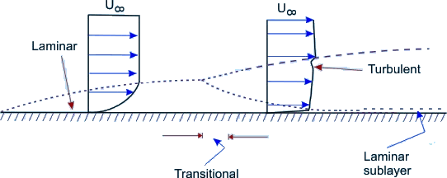
Fig. 3 Laminar - turbulent transition
Observe that at a certain axial location, the laminar boundary layer tends to become unstable. Physically this means that the disturbances in the flow grow in amplitude at this location.
Free stream turbulence, wall roughness and acoustic signals may be among the sources of such disturbances. Transition to turbulent flow is thus initiated with the instability in laminar flow
The possibility of instability in boundary layer was felt by Prandtl as early as 1912.The theoretical analysis of Tollmien and Schlichting showed that unstable waves could exist if the Reynolds number was 575.
The Reynolds number was defined as
where is the free stream velocity , is the displacement thickness and is the kinematic viscosity .
Taylor developed an alternate theory, which assumed that the transition is caused by a momentary separation at the boundary layer associated with the free stream turbulence.
In a pipe flow the initiation of turbulence is usually observed at Reynolds numbers ( )in the range of 2000 to 2700.
The development starts with a laminar profile, undergoes a transition, changes over to turbulent profile and then stays turbulent thereafter (Fig.4). The length of development is of the order of 25 to 40 diameters of the pipe.
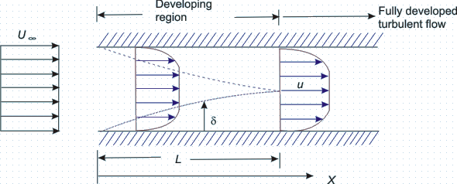
Fig. 4 Development of turbulent flow in a circular duct
Correlation Functions

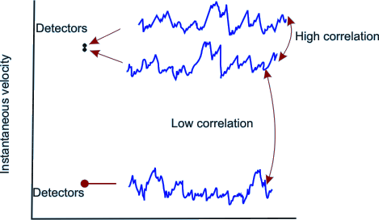
Fig 5 Velocity Correlation
A statistical correlation can be applied to fluctuating velocity terms in turbulence. Turbulent motion is by definition eddying motion. Not withstanding the circulation strength of the individual eddies, a high degree of correlation exists between the velocities at two points in space, if the distance between the points is smaller than the diameter of the eddy. Conversely, if the points are so far apart that the space, in between, corresponds to many eddy diameters (Figure 5), little correlation can be expected.
Consider a statistical property of a random variable (velocity) at two points separated by a distance r. A Eulerian correlation tensor (nine terms) at the two points can be defined by
In other words, the dependence between the two velocities at two points is measured by the correlations, i.e. the time averages of the products of the quantities measured at two points. The correlation of the components of the turbulent velocity of these two points is defined as
It is conventional to work with the non-dimensional form of the correlation, such as
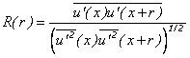
A value of R(r) of unity signifies a perfect correlation of the two quantities involved and their motion is in phase. Negative value of the correlation function implies that the time averages of the velocities in the two correlated points have different signs. Figure 32.6 shows typical variations of the correlation R with increasing separation r .
The positive correlation indicates that the fluid can be modelled as travelling in lumps. Since swirling motion is an essential feature of turbulent motion, these lumps are viewed as eddies of various sizes. The correlation R(r) is a measure of the strength of the eddies of size larger than r. Essentially the velocities at two points are correlated if they are located on the same eddy
To describe the evolution of a fluctuating function u'(t), we need to know the manner in which the value of u' at different times are related. For this purpose the correlation function
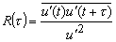
between the values of u' at different times is chosen and is called autocorrelation function.
The correlation studies reveal that the turbulent motion is composed of eddies which are convected by the mean motion. The eddies have a wide range variation in their size. The size of the large eddies is comparable with the dimensions of the neighboring objects or the dimensions of the flow passage.
The size of the smallest eddies can be of the order of 1 mm or less. However, the smallest eddies are much larger than the molecular mean free paths and the turbulent motion does obey the principles of continuum mechanics.
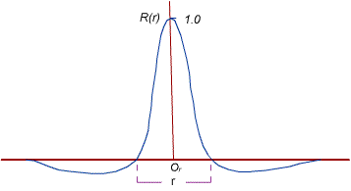
Fig 6 Variation of R with the distance of separation, r
Reynolds decomposition of turbulent flow:
The Experiment: In 1883, O. Reynolds conducted experiments with pipe flow by feeding into the stream a thin thread of liquid dye. For low Reynolds numbers, the dye traced a straight line and did not disperse. With increasing velocity, the dye thread got mixed in all directions and the flowing fluid appeared to be uniformly colored in the downstream flow.
The Inference: It was conjectured that on the main motion in the direction of the pipe axis, there existed a superimposed motion all along the main motion at right angles to it. The superimposed motion causes exchange of momentum in transverse direction and the velocity distribution over the cross-section is more uniform than in laminar flow. This description of turbulent flow which consists of superimposed streaming and fluctuating (eddying) motion is well known as Reynolds decomposition of turbulent flow.
- Here, we shall discuss different descriptions of mean motion. Generally, for Eulerian velocity u , the following two methods of averaging could be obtained.
(i) Time average for a stationary turbulence:
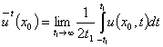

(ii) Space average for a homogeneous turbulence:
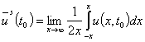
For a stationary and homogeneous turbulence, it is assumed that the two averages lead to the same result: and the assumption is known as the ergodic hypothesis.
- In our analysis, average of any quantity will be evaluated as a time average. Take a finite time interval t₁. This interval must be larger than the time scale of turbulence. Needless to say that it must be small compared with the period t₂ of any slow variation (such as periodicity of the mean flow) in the flow field that we do not consider to be chaotic or turbulent.

Thus, for a parallel flow, it can be written that the axial velocity component is
(1)
As such, the time mean component determines whether the turbulent motion is steady or not. The symbol signifies any of the space variables.
While the motion described by Fig.7(a) is for a turbulent flow with steady mean velocity the Fig.7(b) shows an example of turbulent flow with unsteady mean velocity. The time period of the high frequency fluctuating component is t₁ whereas the time period for the unsteady mean motion is t₂ and for obvious reason t₂>>t₁. Even if the bulk motion is parallel, the fluctuation u ' being random varies in all directions.
The continuity equation, gives us
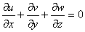
Invoking Eq.(32.1) in the above expression, we get
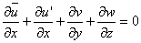 | (2)
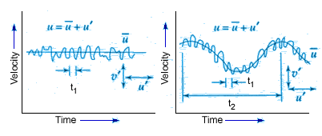
Fig 7 Steady and unsteady mean motions in a turbulent flow
Since 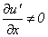 , Eq.(2) depicts that y and z components of velocity exist even for the parallel flow if the flow is turbulent. We have-
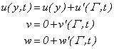 | (3)

However, the fluctuating components do not bring about the bulk displacement of a fluid element. The instantaneous displacement is , and that is not responsible for the bulk motion. We can conclude from the above
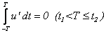

Due to the interaction of fluctuating components, macroscopic momentum transport takes place. Therefore, interaction effect between two fluctuating components over a long period is non-zero and this can be expressed as
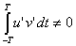
Taking time average of these two integrals and write
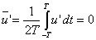 | (4a)
and
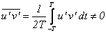 | (4b)
- Now, we can make a general statement with any two fluctuating parameters, say, with f ' and g' as
(5a)

(5b)
The time averages of the spatial gradients of the fluctuating components also follow the same laws, and they can be written as
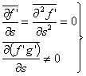 | (6)
- The intensity of turbulence or degree of turbulence in a flow is described by the relative magnitude of the root mean square value of the fluctuating components with respect to the time averaged main velocity. The mathematical expression is given by
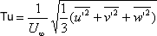 | (7a)
The degree of turbulence in a wind tunnel can be brought down by introducing screens of fine mesh at the bell mouth entry. In general, at a certain distance from the screens, the turbulence in a wind tunnel becomes isotropic, i.e. the mean oscillation in the three components are equal,
In this case, it is sufficient to consider the oscillation u' in the direction of flow and to put
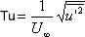 | (7b)
This simpler definition of turbulence intensity is often used in practice even in cases when turbulence is not isotropic.
Following Reynolds decomposition, it is suggested to separate the motion into a mean motion and a fluctuating or eddying motion. Denoting the time average of the component of velocity by and fluctuating component as , we can write down the following,
By definition, the time averages of all quantities describing fluctuations are equal to zero.
(8)
The fluctuations u', v' , and w' influence the mean motion , and in such a way that the mean motion exhibits an apparent increase in the resistance to deformation. In other words, the effect of fluctuations is an apparent increase in viscosity or macroscopic momentum diffusivity .
- Rules of mean time - averages
If f and g are two dependent variables and if s denotes anyone of the independent variables x, y
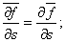
Intermittency
- Consider a turbulent flow confined to a limited region. To be specific we shall consider the example of a wake (Figure 1a), but our discussion also applies to a jet (Figure 1b), a shear layer (Figure 1c), or the outer part of a boundary layer on a wall.
- The fluid outside the turbulent region is either in irrotational motion (as in the case of a wake or a boundary layer), or nearly static (as in the case of a jet). Observations show that the instantaneous interface between the turbulent and nonturbulent fluid is very sharp.
- The thickness of the interface must equal the size of the smallest scales in the flow, namely the Kolmogorov microscale.
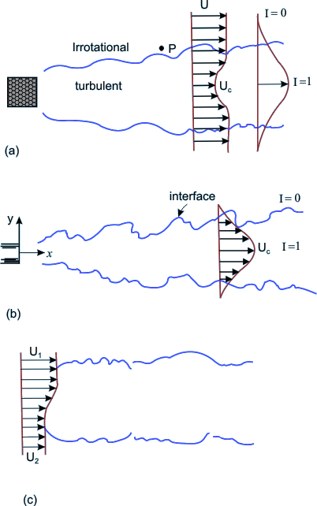
Figure 8 Three types of free turbulent flows; (a) wake (b) jet and (c) shear layer
Measurement at a point in the outer part of the turbulent region (say at point P in Figure 8a) shows periods of high-frequency fluctuations as the point P moves into the turbulent flow and low-frequency periods as the point moves out of the turbulent region. Intermittency I is defined as the fraction of time the flow at a point is turbulent.
The variation of I across a wake is sketched in Figure 8a, showing that I =1 near the center where the flow is always turbulent, and I = 0 at the outer edge of the flow domain.
Derivation of Governing Equations for Turbulent Flow
For incompressible flows, the Navier-Stokes equations can be rearranged in the form
(9a)

(9b)

(9c)
and
(10)

Express the velocity components and pressure in terms of time-mean values and corresponding fluctuations. In continuity equation, this substitution and subsequent time averaging will lead to

or,

Since,

We can write | (11a)
From Eqs (9a) and (9b), we obtain
(11b)

It is evident that the time-averaged velocity components and the fluctuating velocity components, each satisfy the continuity equation for incompressible flow.
Imagine a two-dimensional flow in which the turbulent components are independent of the z -direction. Eventually, Eq.(11b) tends to
(12)
On the basis of condition (12), it is postulated that if at an instant there is an increase in u' in the x -direction, it will be followed by an increase in v' in the negative y -direction. In other words, is non-zero and negative. (see Figure 9)
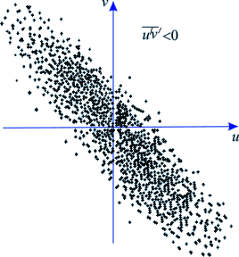
Fig 9 Each dot represents uν pair at an instant
Invoking the concepts of eqn. (8) into the equations of motion eqn (9 a, b, c), we obtain expressions in terms of mean and fluctuating components. Now, forming time averages and considering the rules of averaging we discern the following. The terms which are linear, such as and 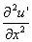 vanish when they are averaged [from (6)]. The same is true for the mixed terms like , or , but the quadratic terms in the fluctuating components remain in the equations. After averaging, they form , etc.

If we perform the aforesaid exercise on the x-momentum equation, we obtain

using rules of time averages,
We obtain
- Introducing simplifications arising out of continuity Eq. (33.3a), we shall obtain.
- Performing a similar treatment on y and z momentum equations, finally we obtain the momentum equations in the form.
In x direction,
(13a)
In y direction,
(13b)
In z direction,
(13c)

- Comments on the governing equation :
  - The left hand side of Eqs (33.5a)-(33.5c) are essentially similar to the steady-state Navier-Stokes equations if the velocity components u, v and w are replaced by , and .
  - The same argument holds good for the first two terms on the right hand side of Eqs (33.5a)-(33.5c).
  - However, the equations contain some additional terms which depend on turbulent fluctuations of the stream. These additional terms can be interpreted as components of a stress tensor.
- Now, the resultant surface force per unit area due to these terms may be considered as
In x direction,
(14a)
In y direction,
(14b)
In z direction,
(14c)

Comparing Eqs (13) and (14), we can write
(15)

It can be said that the mean velocity components of turbulent flow satisfy the same Navier-Stokes equations of laminar flow. However, for the turbulent flow, the laminar stresses must be increased by additional stresses which are given by the stress tensor (15). These additional stresses are known as apparent stresses of turbulent flow or Reynolds stresses. Since turbulence is considered as eddying motion and the aforesaid additional stresses are added to the viscous stresses due to mean motion in order to explain the complete stress field, it is often said that the apparent stresses are caused by eddy viscosity. The total stresses are now
(16)
and so on. The apparent stresses are much larger than the viscous components, and the viscous stresses can even be dropped in many actual calculations.

Turbulent Boundary Layer Equations
- For a two-dimensional flow (w = 0) over a flat plate, the thickness of turbulent boundary layer is assumed to be much smaller than the axial length and the order of magnitude analysis may be applied. As a consequence, the following inferences are drawn:
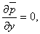

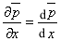

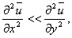

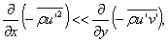

- The turbulent boundary layer equation together with the equation of continuity becomes
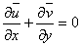 | (17)

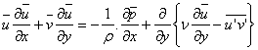 | (18)

- A comparison of Eq. (18) with laminar boundary layer Eq. (17) depicts that: u, v and p are replaced by the time average values and ,and laminar viscous force per unit volume 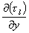 is replaced by 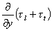 where 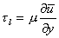 is the laminar shear stress and is the turbulent shear stress.
Boundary Conditions
All the components of apparent stresses vanish at the solid walls and only stresses which act near the wall are the viscous stresses of laminar flow. The boundary conditions, to be satisfied by the mean velocity components, are similar to laminar flow.
A very thin layer next to the wall behaves like a near wall region of the laminar flow. This layer is known as laminar sublayer and its velocities are such that the viscous forces dominate over the inertia forces. No turbulence exists in it.
For a developed turbulent flow over a flat plate, in the near wall region, inertial effects are insignificant, and we can write from Eq.17
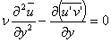

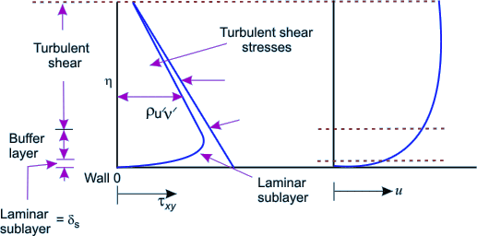
Fig 10 Different zones of a turbulent flow past a wall

which can be integrated as , 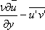 =constant
- We know that the fluctuating components, do not exist near the wall, the shear stress on the wall is purely viscous and it follows
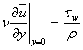
However, the wall shear stress in the vicinity ofthe laminar sublayer is estimated as
(19a)
where U_{s} is the fluid velocity at the edge of the sublayer. The flow in the sublayer is specified by a velocity scale (characteristic of this region).
We define the friction velocity,
(19)

as our velocity scale. Once is specified, the structure of the sub layer is specified. It has been confirmed experimentally that the turbulent intensity distributions are scaled with . For example, maximum value of the is always about . The relationship between and the can be determined from Eqs (33.11a) and (33.11b) as
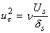
Let us assume . Now we can write
where is a proportionality constant | (20a)
or
(20b)
Hence, a non-dimensional coordinate may be defined as, 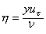 which will help us estimating different zones in a turbulent flow. The thickness of laminar sublayer or viscous sublayer is considered to be .
Turbulent effect starts in the zone of and in a zone of , laminar and turbulent motions coexist. This domain is termed as buffer zone. Turbulent effects far outweight the laminar effect in the zone beyond and this regime is termed as turbulent core .

For flow over a flat plate, the turbulent shear stress ( ) is constant throughout in the y direction and this becomes equal to at the wall. In the event of flow through a channel, the turbulent shear stress ( ) varies with y and it is possible to write
(20c)
where the channel is assumed to have a height 2h and is the distance measured from the centerline of the channel . Figure 33.1 explains such variation of turbulent stress.
Shear Stress Models
- In analogy with the coefficient of viscosity for laminar flow, J. Boussinesq introduced a mixing coefficient for the Reynolds stress term, defined as
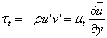
- Using the shearing stresses can be written as
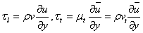
such that the equation
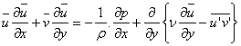
may be written as
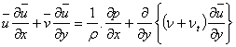 | (21)
The term ν_{t} is known as eddy viscosity and the model is known as eddy viscosity model.
Unfortunately, the value of ν_{t} is not known. The term ν is a property of the fluid whereas ν_{t} is attributed to random fluctuations and is not a property of the fluid. However, it is necessary to find out empirical relations between ν_{t}, and the mean velocity. The following section discusses relation between the aforesaid apparent or eddy viscosity and the mean velocity components

Prandtl's Mixing Length Hypothesis

- Consider a fully developed turbulent boundary layer. The stream wise mean velocity varies only from streamline to streamline. The main flow direction is assumed parallel to the x-axis (Fig. 11).
- The time average components of velocity are given by . The fluctuating component of transverse velocity transports mass and momentum across a plane at y₁ from the wall. The shear stress due to the fluctuation is given by
 | (22)
- Fluid, which comes to the layer y₁ from a layer (y₁- l) has a positive value of . If the lump of fluid retains its original momentum, then its velocity at its current location y₁ is smaller than the velocity prevailing there. The difference in velocities is then

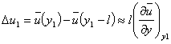 | (23)
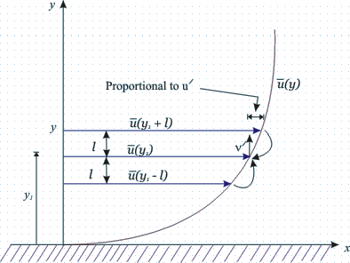
Fig. 11 One-dimensional parallel flow and Prandtl's mixing length hypothesis

The above expression is obtained by expanding the function in a Taylor series and neglecting all higher order terms and higher order derivatives. l is a small length scale known as Prandtl's mixing length. Prandtl proposed that the transverse displacement of any fluid particle is, on an average, 'l' .

Consider another lump of fluid with a negative value of . This is arriving at from . If this lump retains its original momentum, its mean velocity at the current lamina will be somewhat more than the original mean velocity of . This difference is given by

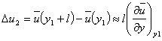 | (24)
The velocity differences caused by the transverse motion can be regarded as the turbulent velocity components at .
We calculate the time average of the absolute value of this fluctuation as

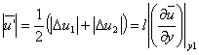 | (25)
- Suppose these two lumps of fluid meet at a layer The lumps will collide with a velocity and diverge. This proposes the possible existence of transverse velocity component in both directions with respect to the layer at . Now, suppose that the two lumps move away in a reverse order from the layer with a velocity . The empty space will be filled from the surrounding fluid creating transverse velocity components which will again collide at . Keeping in mind this argument and the physical explanation accompanying Eqs (33.4), we may state that

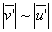
or, 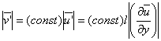
along with the condition that the moment at which is positive, is more likely to be negative and conversely when is negative. Possibly, we can write at this stage

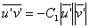
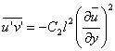 | (26)
where C₁ and C₂ are different proportionality constants. However, the constant C₂ can now be included in still unknown mixing length and Eg. (26) may be rewritten as

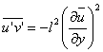
- For the expression of turbulent shearing stress we may write

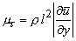 | (27)
- After comparing this expression with the eddy viscosity we may arrive at a more precise definition,

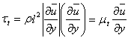 | (28a)
where the apparent viscosity may be expressed as

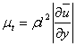 | (28b)
and the apparent kinematic viscosity is given by

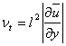 | (28c)
The decision of expressing one of the velocity gradients of Eq. (33.19) in terms of its modulus as was made in order to assign a sign to according to the sign of .
Note that the apparent viscosity and consequently, the mixing length are not properties of fluid. They are dependent on turbulent fluctuation.
But how to determine the value of the mixing length? Several correlations, using experimental results for have been proposed to determine .
However, so far the most widely used value of mixing length in the regime of isotropic turbulence is given by
 | (29)
where is the distance from the wall and is known as von Karman constant .

Universal Velocity Distribution Law and Friction Factor in Duct Flows for Very Large Reynolds Numbers
For flows in a rectangular channel at very large Reynolds numbers the laminar sublayer can practically be ignored. The channel may be assumed to have a width 2h and the x axis will be placed along the bottom wall of the channel.
Consider a turbulent stream along a smooth flat wall in such a duct and denote the distance from the bottom wall by y, while u(y) will signify the velocity. In the neighborhood of the wall, we shall apply

According to Prandtl's assumption, the turbulent shearing stress will be
(30)

At this point, Prandtl introduced an additional assumption which like a plane Couette flow takes a constant shearing stress throughout, i.e
(31)

where denotes the shearing stress at the wall.
- Invoking once more the friction velocity 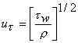 , we obtain
(32)

(33)

On integrating we find
(34)

Despite the fact that Eq. (34) is derived on the basis of the friction velocity in the neighborhood of the wall because of the assumption that = constant, we shall use it for the entire region. At y = h (at the horizontal mid plane of the channel), we have . The constant of integration is eliminated by considering

Substituting C in Eq. (34), we get
(35)

Equation (35) is known as universal velocity defect law of Prandtl and its distribution has been shown in Fig. 12
.
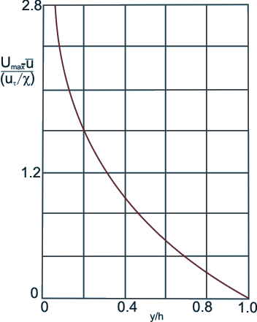
Fig 12 Distribution of universal velocity defect law of Prandtl in a turbulent channel flow

Here, we have seen that the friction velocity is a reference parameter for velocity. Equation (34) can be rewritten as
where

- The no-slip condition at the wall cannot be satisfied with a finite constant of integration. This is expected that the appropriate condition for the present problem should be that at a very small distance from the wall. Hence, Eq. (34) becomes
(36)

- The distance is of the order of magnitude of the thickness of the viscous layer. Now we can write Eq. (36) as

(37)

where , the unknown is included in .
Equation (37) is generally known as the universal velocity profile because of the fact that it is applicable from moderate to a very large Reynolds number.
However, the constants and have to be found out from experiments. The aforesaid profile is not only valid for channel (rectangular) flows; it retains the same functional relationship for circular pipes as well. It may be mentioned that even without the assumption of having a constant shear stress throughout, the universal velocity profile can be derived.
Experiments, performed by J. Nikuradse, showed that Eq. (34.8) is in good agreement with experimental results. Based on Nikuradse's and Reichardt's experimental data, the empirical constants of Eq. (37) can be determined for a smooth pipe as
(38)

This velocity distribution has been shown through curve (b) in Fig. 34.2.
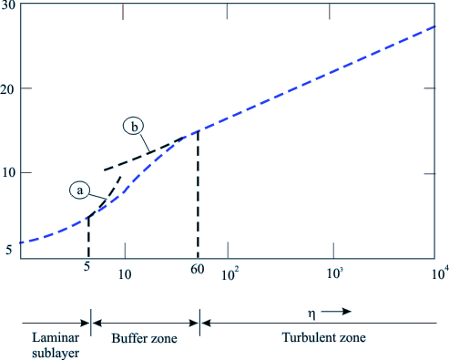
Fig 13 The universal velocity distribution law for smooth pipes

- However, the corresponding friction factor concerning Eq. (38) is
(39)

the universal velocity profile does not match very close to the wall where the viscous shear predominates the flow.

Von Karman suggested a modification for the laminar sublayer and the buffer zone which are
(40)

(41)

Equation (40) has been shown through curve(a) in Fig. 13.

It may be worthwhile to mention here that a surface is said to be hydraulically smooth so long
(41)

where is the average height of the protrusions inside the pipe.
Physically, the above expression means that for smooth pipes protrusions will not be extended outside the laminar sublayer. If protrusions exceed the thickness of laminar sublayer, it is conjectured (also justified though experimental verification) that some additional frictional resistance will contribute to pipe friction due to the form drag experienced by the protrusions in the boundary layer.
- In rough pipes experiments indicate that the velocity profile may be expressed as:
(42)

At the center-line, the maximum velocity is expressed as
(43)

Note that no longer appears with and . This means that for completely rough zone of turbulent flow, the profile is independent of Reynolds number and a strong function of pipe roughness.
However, for pipe roughness of varying degrees, the recommendation due to Colebrook and White works well. Their formula is
(44)

where is the pipe radius
For , this equation produces the result of the smooth pipes (Eq.(38)). For , it gives the expression for friction factor for a completely rough pipe at a very high Reynolds number which is given by
(45)
Turbulent flow through pipes has been investigated by many researchers because of its enormous practical importance.

Fully Developed Turbulent Flow In A Pipe For Moderate Reynolds Numbers
The entry length of a turbulent flow is much shorter than that of a laminar flow, J. Nikuradse determined that a fully developed profile for turbulent flow can be observed after an entry length of 25 to 40 diameters. We shall focus to fully developed turbulent flow in this section.
Considering a fully developed turbulent pipe flow (Fig. 14) we can write
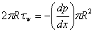 |  | (46)
or
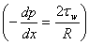 |  | (47)
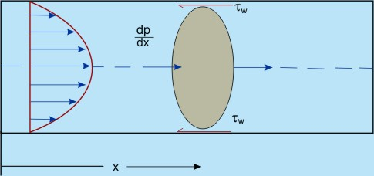
Fig. 14 Fully developed turbulent pipe flow
It can be said that in a fully developed flow, the pressure gradient balances the wall shear stress only and has a constant value at any . However, the friction factor (Darcy friction factor ) is defined in a fully developed flow as
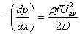 |  | (48)
Comparing Eq. (47) with Eq.(48), we can write
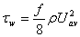 |  | (49)
H. Blasius conducted a critical survey of available experimental results and established the empirical correlation for the above equation as
where | (50)
- It is found that the Blasius's formula is valid in the range of Reynolds number of Re ≤10⁵. At the time when Blasius compiled the experimental data, results for higher Reynolds numbers were not available. However, later on, J. Nikuradse carried out experiments with the laws of friction in a very wide range of Reynolds numbers, 4 x 10³ ≤ Re ≤ 3.2 x 10⁶. The velocity profile in this range follows:
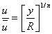 |  | (51)
where is the time mean velocity at the pipe centre and is the distance from the wall . The exponent n varies slightly with Reynolds number. In the range of Re ~ 10⁵, n is 7.

Fully Developed Turbulent Flow in A Pipe for Moderate Reynolds Numbers
- The ratio of and for the aforesaid profile is found out by considering the volume flow rate Q as
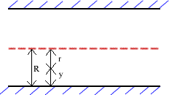
From equation (34.23)
or
or
or
or
(52a)
Now, for different values of n (for different Reynolds numbers) we shall obtain different values of from Eq.(52a). On substitution of Blasius resistance formula the following expression for the shear stress at the wall can be obtained.
putting
and where
or
or

- For n=7, becomes equal to 0.8. substituting in the above equation, we get
Finally, it produces
(52b)
or

where is friction velocity. However, may be spitted into and and we obtain
or
(53a)
Now we can assume that the above equation is not only valid at the pipe axis (y = R) but also at any distance from the wall y and a general form is proposed as
(53b)
- Concluding Remarks:
- It can be said that (1/7)th power velocity distribution law) can be derived from Blasius's resistance formula .
- Equation (52b) gives the shear stress relationship in pipe flow at a moderate Reynolds number, i.e . Unlike very high Reynolds number flow, here laminar effect cannot be neglected and the laminar sub layer brings about remarkable influence on the outer zones.
- The friction factor for pipe flows, is valid for a specific range of Reynolds number and for a particular surface condition.

Skin Friction Coefficient For Boundary Layers On A Flat Plate
Calculations of skin friction drag on lifting surface and on aerodynamic bodies are somewhat similar to the analyses of skin friction on a flat plate. Because of zero pressure gradient, the flat plate at zero incidence is easy to consider. In some of the applications cited above, the pressure gradient will differ from zero but the skin friction will not be dramatically different so long there is no separation.
We begin with the momentum integral equation for flat plate boundary layer which is valid for both laminar and turbulent flow.
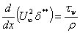 |  | (34.26a)
Invoking the definition of 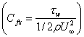 , Eq.(34.26a) can be written as
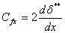 |  | (34.26b)
Due to the similarity in the laws of wall, correlations of previous section may be applied to the flat plate by substituting for R and for the time mean velocity at the pipe centre.The rationale for using the turbulent pipe flow results in the situation of a turbulent flow over a flat plate is to consider that the time mean velocity, at the centre of the pipe is analogous to the free stream velocity, both the velocities being defined at the edge of boundary layer thickness.
Finally, the velocity profile will be [following Eq. (34.24)]
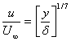 | for | (54)
Evaluating momentum thickness with this profile, we shall obtain
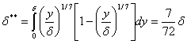 | (55)
Consequently, the law of shear stress (in range of ) for the flat plate is found out by making use of the pipe flow expression.
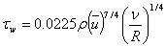

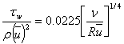
Substituting for and for R in the above expression, we get
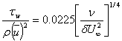 |  | (56)
Once again substituting Eqs (34.28) and (34.29) in Eq.(34.26), we obtain
 | . 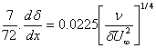
 | 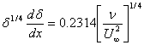
 | 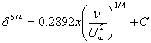 | (57)
- For simplicity, if we assume that the turbulent boundary layer grows from the leading edge of the plate we shall be able to apply the boundary conditions x = 0, δ = 0 which will yield C = 0, and Eq. (34.30) will become From Eqs (34.26b), (34.28) and (34.31), it is possible to calculate the average skin friction coefficient on a flat plate as
or,
or, | (58)
Where
average skin friction coefficient on a flat plate as
(59)
It can be shown that Eq. (59) predicts the average skin friction coefficient correctly in the regime of Reynolds number below .
This result is found to be in good agreement with the experimental results in the range of Reynolds number between and which is given by
(60)
Equation (34.33) is a widely accepted correlation for the average value of turbulent skin friction coefficient on a flat plate.
With the help of Nikuradse experiments, Schlichting obtained the semi empirical equation for the average skin friction coefficient as
(61)
Equations were derived assuming the flat plate to be completely turbulent over its entire length. In reality, a portion of it is laminar from the leading edge to some downstream position. For this purpose, it was suggested to use
(62a)
where A has various values depending on the value of Reynolds number at which the transition takes place.
If the trasition is assumed to take place around a Reynolds number of , the average skin friction correlation of Schlichling can be written as
(62b)
All that we have presented so far, are valid for a smooth plate.
Schlichting used a logarithmic expression for turbulent flow over a rough surface and derived
(63)

Exercise Problems
1.Estimate the power required to move a flat plate, 15 m. long and 4 m. wide, in oil at 4m/sec, under the following cases:
a) The boundary layer is assumed laminar over the entire surface of the plate. (Ans. 1665.5 N-m/sec)
b) Transition to turbulence occurs at and plate is smooth.(Ans. 9486 N-m/sec)
c) The boundary layer is turbulent over the entire plate which is smooth.(Ans. 10023.94 N-m/sec)
d) The boundary layer is turbulent over the entire rough plate with 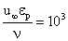 .(Ans. 17200 N-m/sec)
2. Water is transported through a horizontal pipeline, 800 m. long, with a maximum velocity of 3m/sec. If the Reynolds number is , find the diameter of the pipe (with and without the use of Moody Diagram ).
Also calculate the thickness of laminar sub-layer and the buffer layer, and find the power required to maintain the flow. Calculate your results for a fully rough pipe with 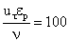 .
(Ans. Diameter of the pipe 0.8 m., laminar sub-layer thickness 0.1 mm, buffer layer thickness 1.3 mm, power required 50250 W)
3. Find the frictional drag on the top and sides of a box-shaped moving van 2.4 m wide, 3.0 m high, and 10.5 m long traveling at 100km/h through air ( ). Assume that the vehicle has a rounded nose so that the flow does not seperate from the top and side. also assume that a turbulent boundary layer starts immediately at the leading edge.
Also, find the thickness of the boundary layer and the shear stress at the trailing edge.
(Ans. Drag = 105.9 N, B.L. = 0.136m, Shear stress = 0.904 Pa)

