1-Introduction:
Amylase is an enzyme that catalyses the hydrolysis of starch into sugars. Amylase is present in the saliva of humans and some other mammals, where it begins the chemical process of digestion.
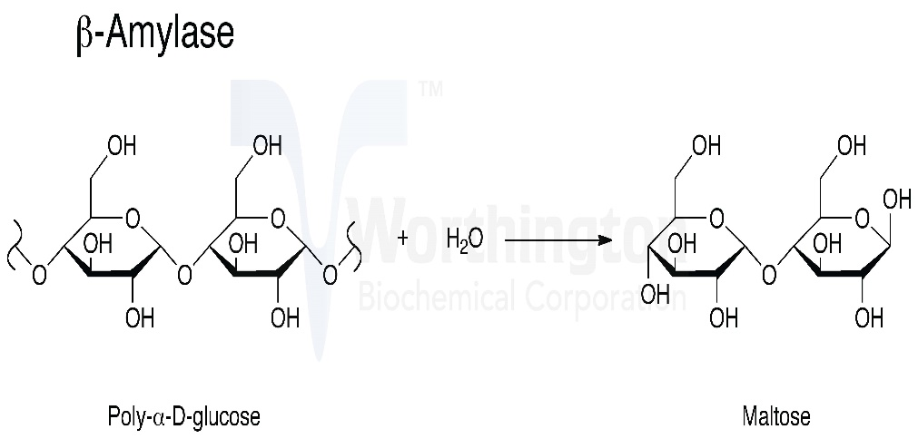
Figure 1 amylase and how it break down strach

Foods that contain large amounts of starch but little sugar, such as rice and potatoes, may acquire a slightly sweet taste as they are chewed because amylase degrades some of their starch into sugar. The pancreas and salivary gland make amylase (alpha amylase) to hydrolyse dietary starch into disaccharides and trisaccharides which are converted by other enzymes to glucose to supply the body with energy. Plants and some bacteria also produce amylase. As diastase, amylase was the first enzyme to be discovered and isolated (by Anselme Payen in 1833) Specific amylase proteins are designated by different Greek letters. All amylases are glycoside hydrolases and act on α-1,4-glycosidic bonds.

2-Objective:
- To estimate the concentration of amylase in serum.

3-Materials:
- GLASSWARE:
1. Accurate pipetting devices.
2. Test tubes / rack
3. Timing device.
4. Heating block /bath (37 oC).
5. Spectrophotometer capable of reading at 405 nm (400-420 nm).
The cuvette compartment should be temperature controlled to maintain temperature (37 oC) during the assay.
- Chemicals:
- Amylase substrate
- Enzyme
3-Method:

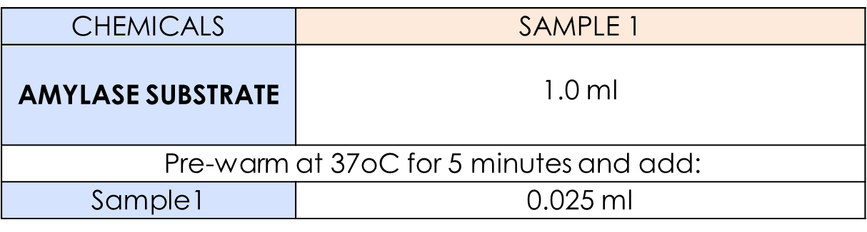
- Mix and incubate at 37oC for 90 seconds and read the absorbance at 405 nm against distilled water.
2. Continue readings every 30 seconds for 2 minutes and determine ΔA/Min.
- The rate of increase in Ab is measured at 405nm and is proportional to the amylase activity in the sample.

4-Result and calculation:

Absorbance at 405 nm | Seconds
0.456 | 0
0.485 | 30
0.508 | 60
0.535 | 90
0.560 | 120

Amylase Activity in TEST (U/L)= ΔA/Min x 4824
A/Min = (Δ A1+ Δ A2)÷2 Δ
Δ A1= ( A 60 s – A30 s)+( A30 s-A0 s)
0.508-0.485)+(0.485-0.456)=0.052)
Δ A2= ( A 120 s – A90 s)+( A90 s-A60 s )
(0.560-0.535)+(0.535-0.508)=0.052
= ΔA/Min x 4824
0.104\2×4824=250.8U/L

Discussion:
في بداية المناقشة مقدمة بسيطة جدا عن التجربة يجب أن توضح و الهدف منها
In this experiment the estimation of plasma amylase was done to indicate …………………………….

بعد ذلك الدخول الى مناقشة النتائج و الاسباب المحتملة اللتي أدت الى ذلك مع الانتباه ان المناقشة لا تكتب على شي نقاط بل على شكل قطع
In the first experiment, the ……….was done and the results was ………..and it could be because

بعد مناقشة النتائج تكتب خاتمة بسيطة عن التجربة و هي مختصر شديد جدا للمناقشة

