.5 The Grade of an Ore
The grade of an ore is the fraction by mass of the valuable material it contains. If:
The mass of the ore = M
The mass of valuable material contained = m
Then the grade (in %) = m/M * 100
Sometimes, the ore is described in terms of its ore mineral content. It can then be converted to metals grade using the appropriate relative atomic masses.
For example, a rock containing 1% of chalcopyrite (CuFeS2) would have a grade of:
1 x 63.5
(63.5+ 56 +2x32)
= 0.34% Cu
where the atomic masses of Cu, Fe and S are 63.5, 56 and 32 respectively.
The grade above which a given deposit is not economic to mine is known as the cut-off grade. Ores well above this value are termed high-grade; those close to this value are termed low-grade.
The multiplication factor needed to reach the cut-off grade from the average crustal abundance is known as the concentration factor. As shown below, this can vary greatly from metal to metal. In general, the greater the concentration factor, the more expensive the metal.
 | Ave. crust | Ave. cut-off (%) | (%)Conc. factor
Aluminium (AI) | 8 | 30 | 3.75
Iron (Fe) | 5 | 25 | 5
Copper (Cu) | 0.005 | 0.5 | 100
Tin (Sn) | 0.0002 | 0.2 | 1000
Gold (Au) | 0.0000004 | 0.0008 | 500
Mercury (Hg) | 0.000008 | 0.2 | 25000

1.6 Size-Grade Characteristics
Grade-tonnage plots usefully depict the metal available in a given deposit for different cut-off grades. There are two extreme deposit types: dispersed and confined. The grade-tonnage plots demonstrate how a small reduction in cut-off grade for the dispersed deposit can generate a significant increase in metals. Secondary enrichment also converts rock to ore.

 | 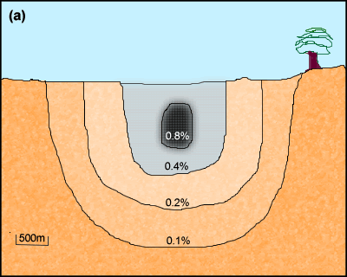
Cut-off grade (per cent) | Reserves of ore/M tonnes ores | Average grade of reserves (per cent) | Reserves of metal/M tonnes metal
0.8 | 50 | 2.0 | 1.0
0.4 | 200 | 1.0 | 2.0
0.2 | 800 | 0.5 | 4.0
0.1 | 3000 | 0.25 | 7.5

Cut-off grade (per cent) Reserves of ore/M tonnes ores Average grade of reserves (per cent) Reserves of metal/M tonnes metal  4.0 0.04 5.0 0.002  3.0 0.3 3.3 0.010  2.0  1.0 1.0 2.2 0.022  0.5 1.1 2.1 0.023 | 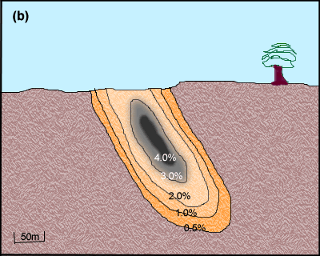
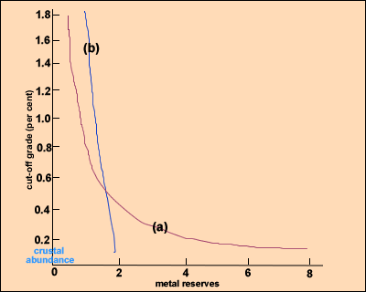 | 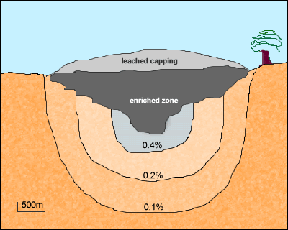

Drag the definitions on left to the corresponding letter on the right by referring to the diagram(Metal - Leachate - Co2,so2 metale- Concentrate – Dust- Co2- Water table

A
B
C
D
E
F
G

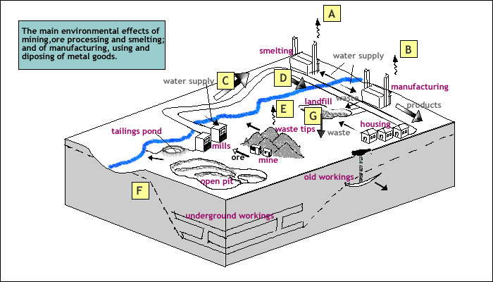

A
B
C
D
E
F
G

