King Saud University
College of Business Administration
Department of Marketing

MKT 403: Digital Marketing
Term1- 2021-2022/ Section

Instructor: Noura AlHadban
E-mail: nalhadban@ksu.edu.sa
Website: http://fac.ksu.edu.sa/nalhadban
Office : Room 8, 2nd Floor, Department of Marketing, Build.3,CBA
Lecture Hours: Sunday, Tuesday, Thursday (9-10/10-11 am)

Course Description
With the explosion of the Internet era and the changing business environment in Saudi Arabia as well as in the world, the demand for knowledge and skills in using online communication tools has been really different and urgent for the current business manpower.
For this reason, this course is essential for marketing students as well as for students from other disciplines. This course provides an overview of the rapidly changing world of marketing, and builds on marketing principles to investigate specialist areas. The Internet and other technologies provide many opportunities for marketing applications. By addressing what is unique about electronic marketing, the course explores how these technologies are creating value for customers as well as benefits for companies and their brands.

Specifically the course deals with issues such as:
- Define what Digital Marketing is and the marketing online activities are.
- Present the Digital Marketing tools and be able to use them effectively.
- Understand the process of a Digital Marketing plan.
- Planning and evaluate a Digital Marketing communication campaign
*Prerequisite: MKT 201

Course Objectives
This course aims to do the following:
- Describe and understand the terminology, concepts, and activities of Digital Marketing.
- Identify the recent developments and their origins in Digital Marketing practice.
- Prepare students to develop an integrated Digital Marketing strategy.

Learning Outcomes
Upon completion of the course, students should be able to:
- Understand the E-Marketing context: e-business models, performance metrics, and role of strategic planning.
- Describe marketing strategies of segmenting, targeting, positioning, and differentiation.
- Know how to use marketing functions of product, pricing, distribution, and marketing communication for a firm's E-Marketing strategy.
- Apply conceptual knowledge and analytical skills to appraise existing and develop new Digital marketing plans
- Develop analytical, critical thinking, and communication and coordination skill

Course Policies

  - The instructor reserves the right to modify any of the material in the Syllabus and Class Schedule with sufficient notice given to course participants.
  - Come to each class well prepared to be able to discuss the required readings and assigned cases and assignments in detail.
  - Each student is responsible for obtaining all handouts, announcements, and schedule changes.
  - Actively participate in lectures and assignment as much of the learning will come from discussions during class.
  - Important class announcements may be communicated by e-mail. You are responsible for checking your e-mail account regularly.
  - Do not come late for class.
  - Switch off your cell phone during class.
  - Do not talk while fellow students are presenting or asking questions.
  - Respect everyone’s opinion.
  - There are no provisions for make-up exams or extra credit.

Class Participation

Individual class assignments will be assigned in the lectures according to the topics each week. Remember your contribution to the classroom discussion based on your knowledge, experiences and performance in this course. Comments from individuals in the class are expected to be relevant, informed, interesting, and insightful. Attendance to class is your responsibility.

Additional Policies
Special Needs: Any such student need to inform Student Affairs Unit for necessary arrangements. After initial provisions are made, kindly coordinate with me.
Academic Misconduct: “Academic Misconduct” by a student includes all acts of dishonesty in any academic matter, and is not limited to cheating, plagiarism, fabrication, or misrepresentation. This can be knowing or intentional help or attempt to help, or conspiracy to help, another student during the process of exams. The Academic Misconduct Code of CBA will be enforced if found guilty. Penalties include a failing grade in an assignment, exam, or course; or any other action decided by the Chairman/ Examination Unit.

Required |Text

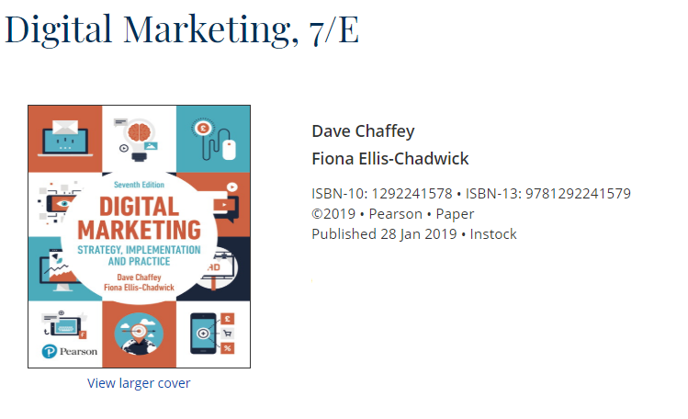

Additional Readings
- Strauss, Judy & Frost, Raymond (2014). E-Marketing. 7th ed. UK: Pearson EducationInc.

Make-up exams are not permitted except in cases of verified emergencies or other special circumstances, and the burden of producing verification would be yours. In such cases, you must still notify me at the earliest possible opportunity, and submit evidence to document the special circumstances (do not wait to be asked to do so). Make-up exams will be held on week 14th covered all the chapters discussed in this semester.

Assignments

Objectives for Assignments
An underlying assumption of the Digital Marketing course is that students learn best and retain more when they actively apply and work with the concepts presented in the course materials rather than simply read about them or hear the professor talk about the ideas. The purpose of these assignments is for you to apply concepts and tools learned in class to real situations. In general, each of the assignments will be graded according to the following criteria:
- Evidence of understanding and ability to apply course concepts
- Quality (depth, creativity, clarity) of analysis and expression.
- Writing style, you will not receive extra credit for proper spelling, grammar, punctuation, etc., but will receive a poor evaluation of the assignment if these areas are found to be lacking.
- The submission due dates.

Project Report and Presentation
The project work is a group task and includes development of electronic marketing plan for any business of choice. Each group has to submit one report, no later than the date and time noted in the schedule. Late submission maybe acceptable, but will be subject to a 2 marks deduction from the score received, irrespective of the quality of work. No excuses will be accepted after the final date of submission.
The project presentation is a group activity, but each student will present her contribution in the research. Each student will be judged on the basis of his contribution to the report and understanding of the entire work.
The project is intended to let the students focus on a particular aspect of electronic marketing. Students will use secondary data sources (library resources, relevant websites, etc.) and may conduct personal interviews with customers and key stakeholders of a retailer of their choice and write a project report where they present their findings (see Appendix for project guideline and more details). The project would require students to take initiative, think, and make decisions on their own. The instructor will only assist in decision-making and will not make the decision for the students.
Important: Project report will be graded based on the following criteria:
- Evidence of understanding and ability to apply course concepts
- Quality of research (depth, breadth, appropriateness) and proper acknowledgement, including complete citations of references.
- Quality of analysis and thoughtfulness of the conclusions and suggestions.
- Appropriate language and tone, accurate spelling, correct grammar, appropriate punctuation, and logical organization. You will not receive the full point if your writing is awkward, contains significant grammatical or punctuation errors, or is disorganized. One point may be deducted for each grammar and/or spelling mistake.

Submissions:
All submissions are Only through the blackboard.

Appendix: Project Guidelines

Technical Specification
5 to 10 pages of report (excluding the cover page and interview transcripts) in Times New Roman with 12- point font, double space, A-4 paper size with one inch margins and page numbers inserted on the top right of the page.

The format of the plan will be uploaded to Blackboard.

Project Process
- Every group of students may select one firm that either Virtual or has a presence on the Internet (i.e., a website which is used to market and sell the firm’s products and services) as well as a physical presence (i.e., a physical store to market and sell the firm’s products and services) such as Jarir bookstore, Altayar, Othiam Market, Dunkin Donuts etc.
- After selecting the firm, the student will gather secondary data about the firm, its revenue, profit, market size, the contribution made by the web-section and social networking activities of the firm, etc. You can use library resources, industry magazines, newspaper articles, etc. You must cite these resources in your report.
- You have to assess e-marketing strategies and present clear recommendations to enhance them.
- All questions should be addressed to your instructor through email.

Project Report Outline:
A maximum of 10 pages or a minimum of 5 pages (not counting the cover page) including points 1 through 6 as mentioned below; the transcript of interviews could be in addition to these 10 pages.
Important: Language is an important aspect of the project report. Write in a level that is appropriate to the business community. Effective writing helps clarify ideas and communicate those ideas to others. Be organized, clear, and succinct. Grammar, punctuation, style, and spelling count. One point will be deducted for each grammar and/or spelling mistake.
Submission: You must submit your project electronically (in Microsoft Office Word and PDF format) through Blackboard. There is no possibility for late submission. You must submit your project report by the deadline specified in course schedule.

Course Evaluation:

•Midterm1  (Essay questions +T/F+MCQ) | 20% | W5 (chap1/2/3)  30/09/2021
•Midterm2  (Essay questions +T/F+MCQ) | 20% | W9 (chap 4/5/6)  26/10/2021
- Case analysis/Mini research & other assignments | 5% | W10- 25/3/2021
- Team project & presentations | 15% | W15- 16  Submission 05/12/2021  Presentation 5-7-9/12/2021
- Final Exam | 40% | (Chap 1/5/ 9/10)  23/12/2021
- Total | 100%

Course Content:

In the Digital Marketing course there are essential topics that should be covered; these topics are listed in the table below

Week | Topic and Assignment | Book Reading
Week 1 | Introduction &Orientation
Week 2 | Introduction to Digital Marketing | Chapter 1
Week 3 | Digital Microenvironment | Chapter 2
Week 4 | Digital Macro Environment | Chapter 3
Week 5 | Digital Marketing Strategy | Chapter 4
Week 6
Week 7 | Digital Media and the Marketing Mix | Chapter 5
Week 8
Week 9 | Relationship Marketing on Digital Platforms | Chapter 6
Week 10
Week 11 | Digital Marketing Communications | Chapter 9
Week 12
Week 13 | Evaluation & improvement of digital channel performance | Chapter 10
Week 14 | Project Presentations | ------------------

