King Saud University  College of Applied Studies and Community Service  Natural Science and Engineering Program | 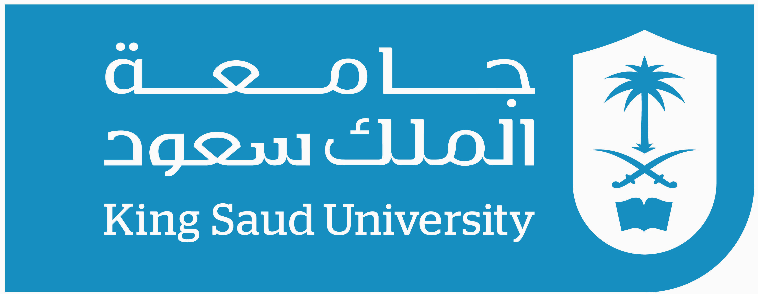

Communication Systems Lab (2)
1402CT
2nd Semester 1438/1439

Instructor:Nour Alhariqi
Email:nalhareqi@ksu.edu.sa noor.ksu@gmail.com
Office Hours: MON: 12- 1 TUS: 11-1 WED: 1-2
Credit Hours: 3 (1+4+0)
Course Objectives:

- - Understanding digital transmission of digital data.
- - Understanding digital transmission of analog signals.
- - Understanding analog transmission of digital data.
- - Understanding the function of MODEMs.
- - Understanding different types of noise in communication systems.
- - Understanding optical transmission systems.

Course Learning Outcomes:

1) Describe different types digital encoding; RZ, NRZ and Manchester.
2) Understand PCM and Delta modulation techniques.
3) Recognize and implement digital modulation techniques; ASK, FSK and PSK.
4) Describe the operation of FSK-based MODEMs.
5) Understand and calculate the effect of noise on received signal quality.
6) Use different types of filters to reduce the effect of noise on signals
7) Using optical fiber to transmit analog and digital signals.
8) Setup, conduct and analyze experiments in digital communication.

Grading Policy:
First Mid 20% Date:
Second Mid 20% Date:
Evaluation 10%
Homework 10%
Final Exam 40%

Class Rules:
- Please print lecture notes and lab worksheets.
- No late homework will be accepted.
- Attendance is very important.
- If you are late you may attend but you will be considered absent.
- If you miss one of the major exams you will be not excused unless the instructor accepts your formal medical report and it will cover both Mids

