**A.2 Software Track Final Report Template**

The following is the final 496/497 report for the software track.

* These sections should be modified based on the phase of the graduation project.

** These sections are to be included in the final report of CSC497

**Project Title**

**Abstract\*** The abstract should complement your proposal abstract and might include any additions that do not contradict the new proposal abstract.

**1. Introduction**

The introduction chapter is a very important for introducing the topic of your project. A great introduction gets the readers’ attention and keeps them excited about reading your project report. Generally, the introduction must contains the following:

* Problem description
* Introduction of the general topic that the project falls within.
* Motivation showing why readers should be interested on your topic.
* Introduction of your research/product, where you give a brief description of your research question (thesis) or what your product is trying to solve.
* Brief description of your solution: While it is not critical at this stage to explicitly state your entire proposed approach, it might help to roughly describe your solution.
* Finally, an organization paragraph that shows the remainder layout of the report.

**2. Background**

This chapter should include the definition and the notations you will be using later in your report. It should introduce the user to any concepts, terms, algorithms, or tools you will be using in your project. This is where you should lay down any definitions, acronyms that will show up in your report.

**3. Literature Review**

This is the main chapter in the midterm report. In this chapter, you should show familiarity with the literature. By exposing the reader to the relevant published work. The literature review should be comprehensive for the problem you are writing about. The purpose of this chapter is to put your work in context with others, and benefit from their experience. You may mention any changes that you have made to your original solution after you have conducted the literature review. At least 3 sources for software projects should be reviewed thoroughly.

**4. Software Design\***

**4.1 Requirements**

List all function and on-functional requirement

**4.2 Software Design**

Show your software design using any or all of the following diagrams/subsections. The reader/examiner should have a clear understanding of your design.

**System use-cases:** This section lists use cases or scenarios to represent some significant, central functionality of the final system

**Analysis class:** Here you identify all the boundary class, control class and entity class for all the use cases. You should also identify the attributes ad methods in the classes.

# Interaction Diagram: Here you show the interaction in terms of sequence or communication diagram between the objects/classes for different use case scenarios. You may ignore the trivial use cases. You can also show the interaction in case of exceptional flows in a use case. Exceptional flows include the following:

* + Error handling. What should the system do if an error is encountered?
  + Time-out handling. If the user does not reply within a certain period, the use case should take some special measures.
  + Handling of erroneous input to the objects that participate in the use case (for example, incorrect user input).

# Design Class: Here you give the diagram of the design classes, that is more refined than the analysis class model- it should also include the attributes and the methods.

# System Architecture: Provide the software architecture diagrams and descriptions

# User Interface Prototype: Provide screen shots of the developed user interfaces, or mockups to illustrate the looks and feel of the system for critical scenarios

# Database Schema: If you need to use database, define the relevant schemas or file formats. Illustrate how your example data will be stored.

# Algorithms: Give brief overview of any special algorithms you will use e.g. image processing, game strategy, scheduling etc.

# Expected Deployment: See example

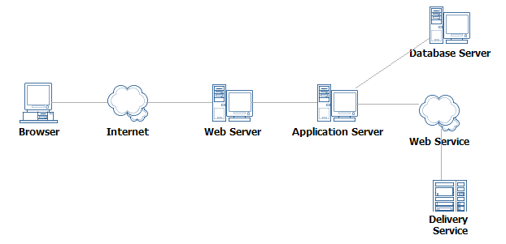

**Test Scenario:** You need to specify some important test cases for some scenarios by identifying sample input and expected output of the system’s core component/classes.

**5. Software Description\*\***

First provide a short description of the application to familiarize reader about your development work.

**5.1 Implementation Platform**

Provide list of technologies hardware/software in addition to implementation platform used.

**5.2 Mapping between Requirements and Implemented Functions**

The following table shows a mapping between the projected functionalities of the system and the corresponding implemented modules.

**Table 1. Test Table**

|  |  |
| --- | --- |
| **Functional requirements** | **Modules/Functions/Class that implemented this feature** |
| Search facility | SearchByKeyword(string str) |
|  | SearchAdvance(String title, String year) |
| ………………… |  |

**5.3 Implementation Details**

Here you try to give the details of interface and program main logic. Say what is the starting point of the system and what is the GUI interface (if any). Then you give a walkthrough of the system by showing the sample interfaces to demonstrate other functionalities. At the same time, you try to explain the main logic in each important function. Provide code snippet to show the main logic, do not give the whole code. The following is an example.

**5.3 Actual Database Schema** (if a database is used)

Here you give the actual ER diagram for the database you have finally designed. Additionally, you can also provide another view with attribute name and types

**5.4 Deployment of the System**

Provide a figure/description to clarify the actual deployment of the system

**5.5. Limitation of the System**

here you explain what u wanted to do but could not………….

**6. Conclusion\***

Clear, insightful statement that summarizes your work. This chapter summarizes your project. You should mention the major findings/output of your project. This should take the place of the Summary section from the midterm report in CSC496.

In CSC497, you may add any future directions you foresee for the project

**References** A bibliography of all cited works and sources you have used in your report.