**IE-352**

**Section 1, CRN: 13536**

**Section 2, CRN: 30521**

**First Semester 1434-35 H (Fall-2013) – 4(4,1,2)   
“MANUFACTURING PROCESSES – 2”**

**Sunday, November 10, 2013 (07/01/1435H)**

**Quiz 3 ANSWERS**

|  |  |  |
| --- | --- | --- |
| **Name:**  **AHMED M. EL-SHERBEENY, PHD** | **Student Number:**  **4** | **Section:**  **11:00 / 1:00** |

**Examine the drawing below and answer the following questions. [units: $in$]**

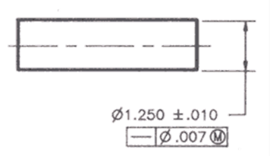

1. **What type of geometric tolerance is involved here (form, orientation, or location)?** [*1 Point*] **ANSWER:**

**form**

1. ***Describe* below each element of the *feature control frame*.** [*3 Points*]

* : geometric – form – **straighness** tolerance
* : allowable geometric tolerance is a $0.07 in$ **cylindrical error zone** 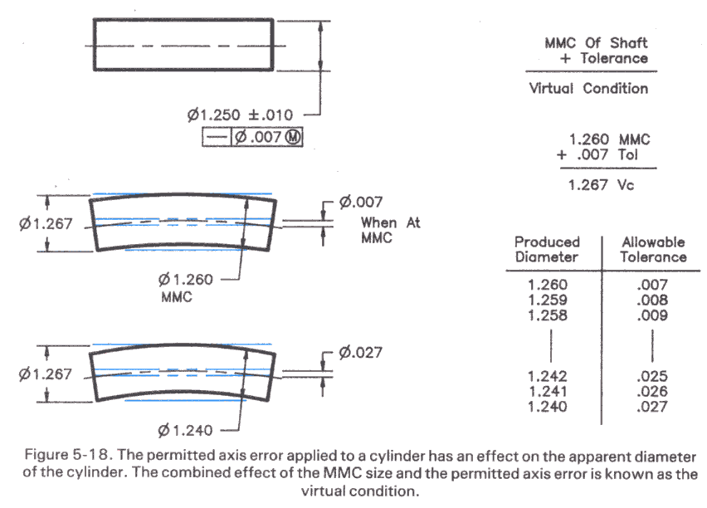 measured around the central axis (or axis error) and is taken at the $MMC$ **of the shaft**

1. **What is the basic size?** [*1 Point*] **ANSWER:**
$$1.250 in$$

2. **What is the MMC and LMC?** [*1 Point*]

**MMC:**

$$1.260 in$$

**LMC:**

$$1.240 in$$

$MMC = BS+0.010=1.260$**; $LMC = BS-0.010=1.240$**

1. **What is the size of the *virtual hole*?** [*2 Points*] **ANSWER:**
$$1.267 in$$

$$virtual hole: V_{c}= ϕ_{shaft@MMC}+{GT}_{MMC}= 1.260+0.007=1.267 in$$

2. **What is the geometric tolerance for cross sections in the shaft having the following sizes?** [*2 Points*]
   1. 1.256 **ANSWER:**
 $$0.011 in$$

  2. 1.238 **ANSWER:**

**part rejected**

$size=1.256$

* Check size: $1.240<1.256<1.260$ (⇒ ok)
${GT}_{1.256}=V_{c}-size=1.267-1.256=0.011$

$size=1.238$

* Check size: $1.238<1.240 (LMC)$ (⇒ **part is rejected**)