Standard Deviation
The Standard Deviation is a measure of how spread out numbers are.

Variance
The average of the squared differences from the Mean.

Mean
The mean is the average of the numbers. In other words, it is the sum divided by the count.

Median
The Median is the “middle” of a sorted list of numbers.
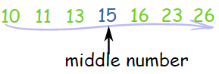

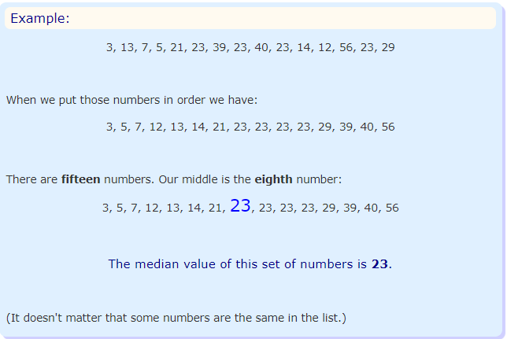

Two Numbers in the Middle
BUT, with an even amount of numbers things are slightly different.
In that case we find the middle pair of numbers, and then find the value that is half way between them. This is easily done by adding them together and dividing by two.
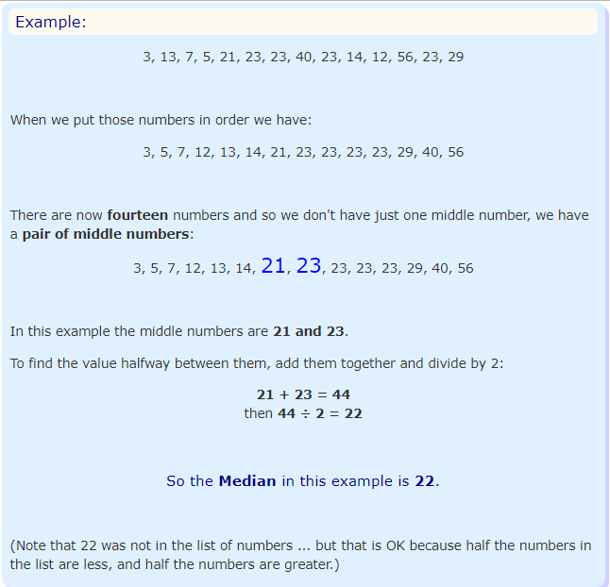

Where is the Middle?
A quick way to find the middle: count how many numbers, add 1 then divide by 2.

Mode
The mode is simply the number which appears most often.
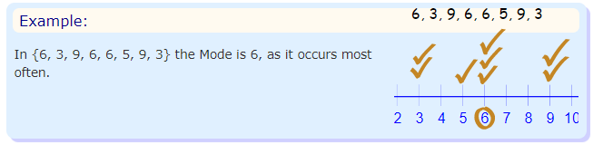
Finding the Mode
To find the mode, it is best put the number in order. Then count how many of each number. A number that appears most often is the mode.

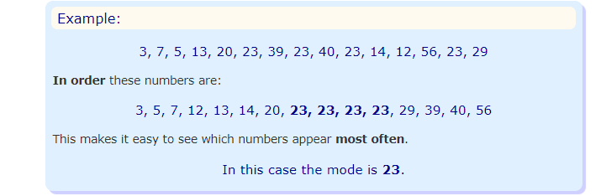

Standard Error of the Mean (SEM)
The Standard Error of Mean, also known as SEM is another measure of variability of data. It is an estimate of the deviation of a sample mean from the population mean. SEM is not as popular as standard deviation, and it is sometimes just referred to as “standard error”.

