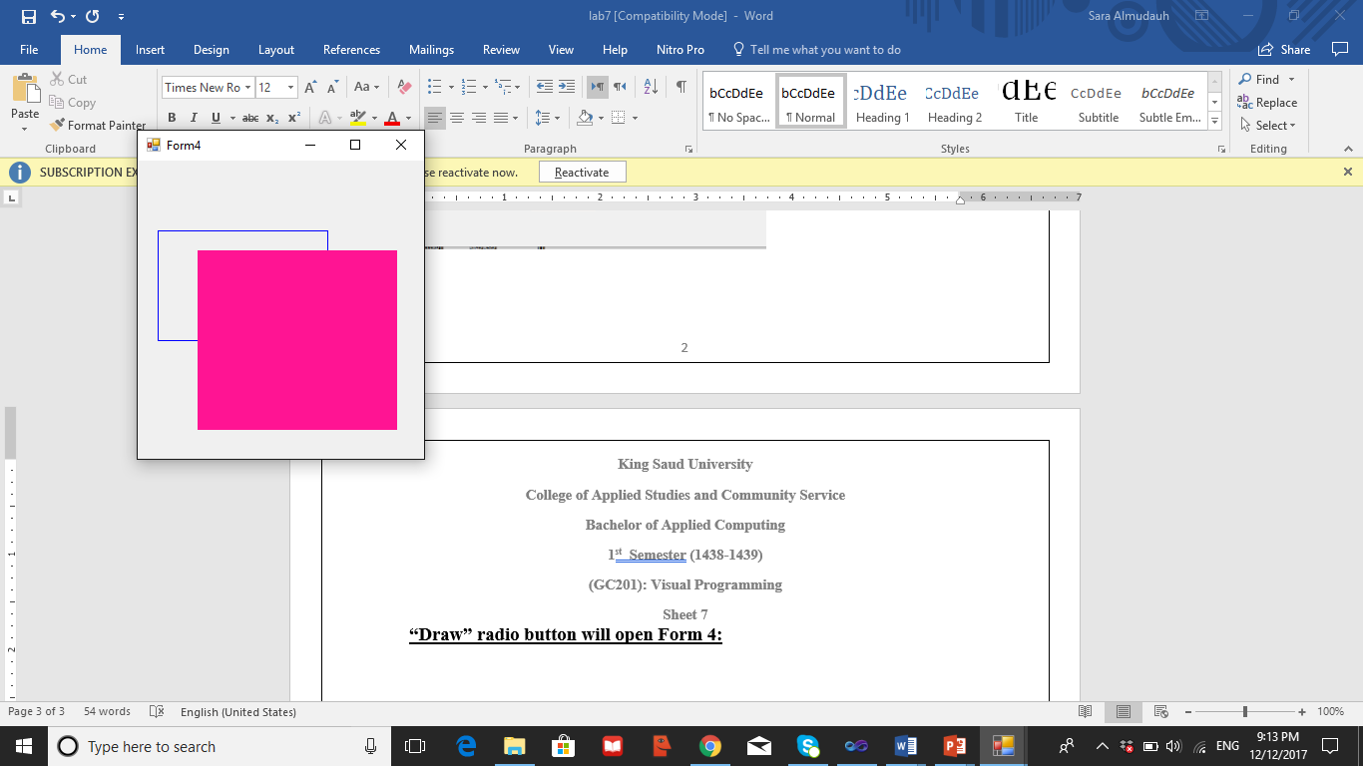

Drew the shapes as you see in the figure

1. The background rectangle width = 170 , Height = 110 and (20,70) coordinates.
2. The filled rectangle width = 200 , Height = 180 and (60,90) coordinates.