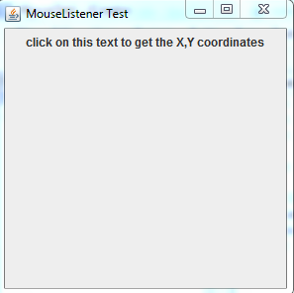
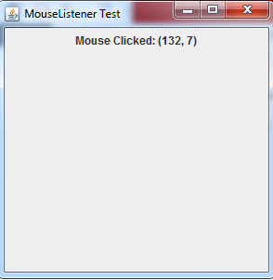
Write a java application using mouse listener. When the user clicks on the panel the program shows the coordinates of the mouse click.

