Good programming practice:

* **Start your program with a comment**
* **The last character printed in any output statements should be a new line**
* **Indent your code to make it more readable**

**Q1. Edit, compile and run the following program, and observe the output produced.**

#include<iostream>

using namespace std;

int main()

{

cout<<"Welcome to C++ programming \n";

return 0;

}

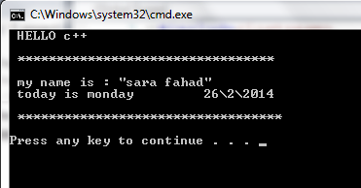**Q2. Write a program that prints your information formatted as shown below**