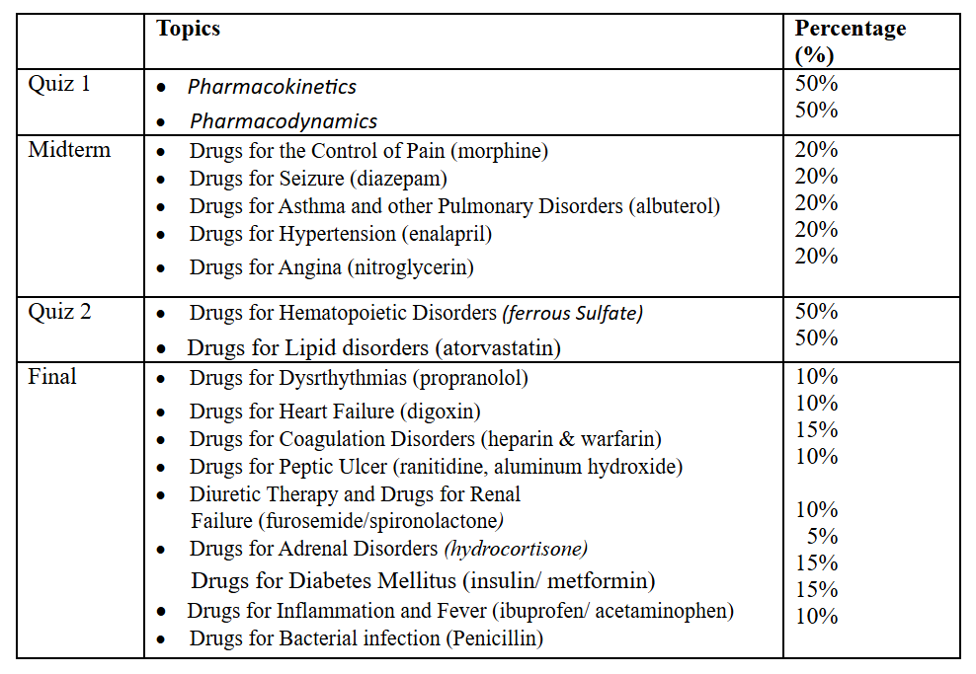
- Date for Quiz-1 will be 15/2/2026; Topics include Pharmacokinetics, Pharmacodynamics.

- Date for Quiz-2 will be 3 May, 2026; Drugs for Hematopoietic Disorders (ferrous Sulfate), Drugs for Lipid disorders (atorvastatin).

- Midterm

