References
By Betty Bates Tempkin - Ultrasound Scanning: Principles and Protocols: 3rd (third) Edition
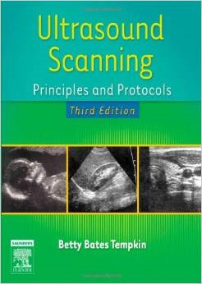

Sonography: Introduction to Normal Structure and Function

