RDS  110

Dental Anatomy and Morphology

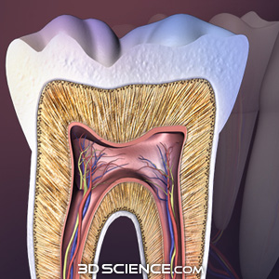 

***COURSE DESCRIPTION***

This is the first pre-clinical operative course that consists of one main component, Dental Anatomy and Morphology.  This course is provided by the RDS Department in the first semester during the first year of the BDS program. It is a (1+1+0) course, equivalent to 2 credit hours. It is designed to provide the student with the basic elements of tooth morphology as an essential pre-requisite for other dental courses. The course comprises lectures and practical sessions. Using wax, students restore the missing coronal surfaces of complete tooth models by a wax carving technique. This is designed to reinforce the theoretical knowledge gained in the lectures, as well as contribute towards the development of manual dexterity, a skill which is essential in the practice of dentistry. Identification of natural tooth specimens forms a significant part of the practical component of the course.

For full details of the course specification and outline, [click here](http://faculty.ksu.edu.sa/aljamhan/Documents/RDS%20110%20course%20outline%20and%20specification%20(2013).pdf)

To download and print the laboratory and practical manual, [click here](http://faculty.ksu.edu.sa/aljamhan/Documents/Laboratory%20manual.pdf)