KING SAUD UNIVERSITY
COLLEGE OF DENTISTRY

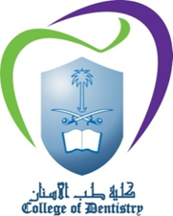

COURSE OUTLINE

Course Title : COMPREHENSIVE CLINICAL DENTISTRY
Course Code : 493 DEN
Academic Year : 1436-1437H (2015-2016G)

