KING SAUD UNIVERSITY
COLLEGE OF DENTISTRY

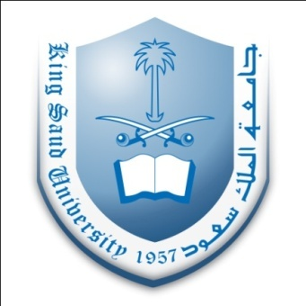
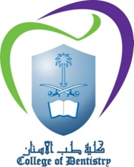

COURSE OUTLINE

Course Title : CLINICAL OPERATIVE DENTISTRY - I
Course Code : 313 RDS
Department : Department of Restorative Dental Sciences
Academic Year : 1436-1437H (2015-2016G)

