IE-341
Section 1, CRN: 30512/513/514
Section 2, CRN: 30515/516/517
Section 3, CRN: 46950/951/952
First Semester 1435-36 H (Fall-2014) – 3(2,1,2)
“HUMAN FACTORS ENGINEERING
Wednesday, November 05, 2014 (12/01/1436H)
Quiz 2 ANSWERS

Name: | Student Number:  4 | Section:  Sun / Mon / Wed

Part A. Answer the following questions briefly. [2 points each]
- Which of the following figures best describes the Hick-Hyman Law? (circle the correct letter)
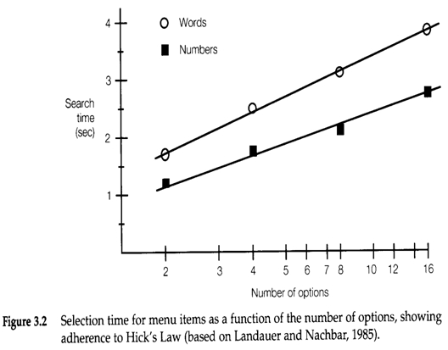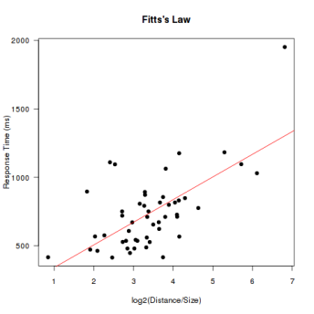
a
b
c
- Briefly state the Hick-Hyman Law in your own words.
The reaction time [$sec$ or $msec$] required to respond to a stimulus [$Bits$] increases linearly as the probability [$p_{i}$] of occurrence of events departs from equal likelihood (i.e. as uncertainty increases). (see slide 3-I-8)

Part B. Fill in the blanks. [1 Point Each]
- For any display, the original source of information is called the ………………… stimulus.
Distal or external (see slide 3-II-3)

- Watching TV is an example of …………………, indirect sensing of information.
Reproduced (see slide 3-II-4)

- A map is an example of ………………… information or display.
Representational (see slide 3-II-7)

- ………………… presentation is recommended when the message will not be referred to later.
Auditory (see slide 3-II-8)

- Identifying the photo of a person with someone’s real name is an example of ………………… judgment.
Absolute (see slide 3-II-11)

- The ………………… of a coding system allows it to be used by different people in different situations.
Standardization (see slides 3-II-13)

