IE-341
Section 1, CRN: 30512/513/514
Section 2, CRN: 30515/516/517
Section 3, CRN: 46950/951/952
First Semester 1435-36 H (Fall-2014) – 3(2,1,2)
“HUMAN FACTORS ENGINEERING
Wednesday, November 05, 2014 (12/01/1436H)
Quiz 2 ANSWERS

Name: | Student Number:  4 | Section:  Sun / Mon / Wed

Part A. Answer the following questions briefly. [2 points each]
- Which of the following figures best describes Fitts’s Law? (circle the correct letter)
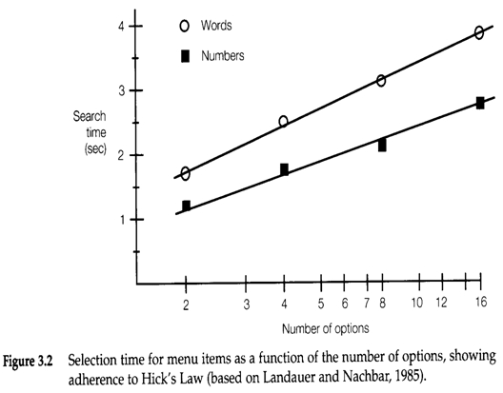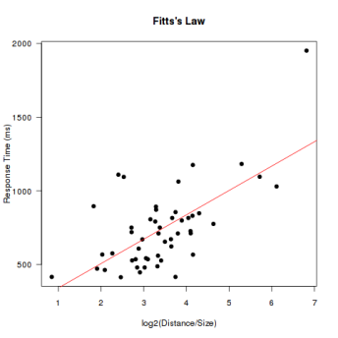
a
b
c

- Briefly state Fitts’s law in your own words.
The reaction time [$sec$ or $msec$] to reach a target is an inverse function of the distance to [D] and size [W] of the target. (see “Fitts’ Law Demonstration Web Site” http://fww.few.vu.nl/hci/interactive/fitts/)

Part B. Fill in the blanks. [1 Point Each]
- For indirect sensing the stimuli can either be ………………… or coded.
Reproduced (see slide 3-II-4)

- Speed gages are an example of ………………… information or display.
Quantitative or dynamic (see slides 3-II-5,6)

- Traffic lanes are an example of ………………… information or display.
Identification or qualitative or static (see slide 3-II-5,6,7)

- ………………… presentation is recommended when the message does not call for immediate action.
Visual (see slide 3-II-8)

- Frequency represents a(n) ………………… of the auditory stimulus.
Dimension (see slide 3-II-10)

- The number of coding levels is important in the ………………… of a code.
Discriminability (see slides 3-II-12)

