IE-341
Section 1, CRN: 30512/513/514
Section 2, CRN: 30515/516/517
Section 3, CRN: 46950/951/952
First Semester 1435-36 H (Fall-2014) – 3(2,1,2)
“HUMAN FACTORS ENGINEERING
Wednesday, November 05, 2014 (12/01/1436H)
Quiz 2 ANSWERS

Name: | Student Number:  4 | Section:  Sun / Mon / Wed

Part A. Answer the following questions briefly. [2 points each]
- Which of the following figures best describes Hick’s Law? (circle the correct letter)
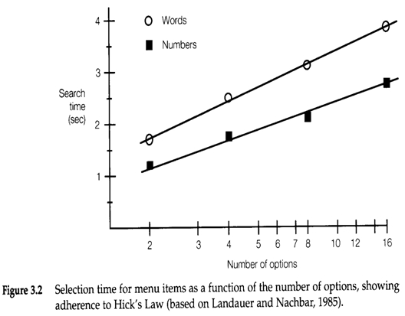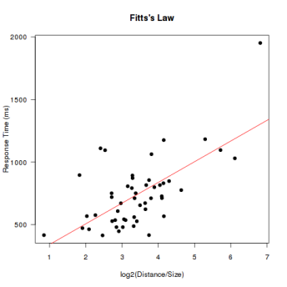
a
b
c

- Briefly state Hick’s law in your own words.
The reaction time [$sec$ or $msec$] required to respond to a stimulus [$Bits$] increases linearly as the number of equally likely alternatives [$N$] increases. (see slide 3-I-8)

Part B. Fill in the blanks. [1 Point Each]
- Human factors engineering is concerned with ………………… sensing.
Indirect (see slide 3-II-4)

- Traffic lights are an example of ………………… information or display.
Status or dynamic or qualitative (see slide 3-II-5,6)

- Printed material is an example of ………………… information or display.
Alphanumeric and symbolic or static (see slide 3-II-7)

- ………………… presentation is recommended when the person’s job requires moving around continually.
Auditory (see slide 3-II-8)

- Identifying one sound as being louder than another is an example of ………………… judgment.
Relative (see slide 3-II-11)

- ………………… compatibility is related to the meaningfulness of a coding system.
Conceptual (see slides 3-II-12,15)

