Quiz (1)

Name: ID:

1. 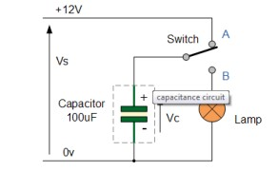**Calculate the charge in the below circuit.**

**Q=C*V = 100 *10-6  F * 12 V = 1200 *10-6 C**

1. **In the below circuit calculate**
2. **the equivalent capacitance of the capacitors.**
3. **the total charge that can be stored in the capacitors.**
4. 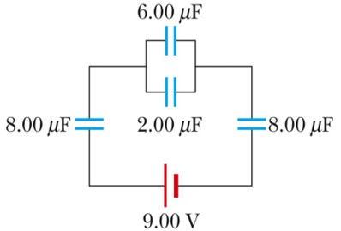**draw the equivalent circuit (write the new value)**

Firstly, find the capacitance equivalent for these connected in parallel:

Ceq= 6+2 = 8µF

Secondly, find the equivalent capacitance for the three capacitor connected in series:

1/Ceq= (1/8)+ (1/8)+(1/8)=(3/8)µF

a) Then Ceq=(8/3)= 2.67 µF

b) Total Q= CV= 2.67×10-6×9 = 24×10-6 C

**3. Suppose there is a positive charge placed in the space. Show the direction of the electric field and which point expose to high electric force a, b, c, d?**

