كلية العلوم
قسم الإحصاء وبحوث العمليات
College of Sciences
Department of
Statistics and Operations Research

Quiz 2
Nonparametric Statistical Methods
(STAT 333)
______________________________________________________

Name :_________________ _________________________ _________

Student ID :_______ _________________________ _________________

Signature :__________ _________________________ ______________
______________________________________________________

ANSWER ALL THE FOLLOWING QUESTIONS:
Question 1 (8 marks total):
- Suppose that we have a random sample of size n. For α = 0.05, if the Z-score of the skewness of the sample is (−2.032), then the sample has Therefore, either the sample must be modified and rechecked or you must use a nonparametric statistical test.
(A) | Pass the normality assumption for kurtosis | (B) | Pass the normality assumption for skewness.
(C) | Failed the normality assumption for kurtosis | (D) | Failed the normality assumption for skewness.
- Consider the following two independent samples:
Sample A: 15 17 18
Sample B: 14 16 19 19 20 22 23
The value of the test statistics for a right-tail Wilcoxon rank test is:
(A) | 3 | (B) | 7
(C) | 11 | (D) | 44
- In testing for the difference between two populations, it is possible to use _________
(A) | The Wilcoxon Rank-Sum test | (B) | The Sign test
(C) | Either of (A) or (B) | (D) | None of these
- Which of the following is not true of parametric statistics?
(A) | They are inferential tests | (B) | They assume certain characteristics of population parameters
(C) | They assume normality of the population | (D) | They are distribution-free
- A collection of statistical methods that generally requires very few, if any assumptions about the population distribution is known as________
(A) | parametric methods | (B) | nonparametric methods
(C) | semiparametric | (D) | none of these
- A nonparametric method for determining the differences between two populations based on two matched samples where only preference data is required is the
(A) | Mann-Whitney-Wilcoxon test | (B) | Wilcoxon signed-rank test
(C) | Sign test | (D) | Kruskal-Wallis Test
- Parametric tests are based on some restrictive assumptions about the _____________.
(A) | Random sample | (B) | Census
(C) | Sample | (D) | Population
- The Mann-Whitney U test is preferred to a t-test when _________
(A) | Data are paired | (B) | Sample sizes are small
(C) | Sample are dependent | (D) | The assumption of normality is not met
Question 2 (4 marks total):
For each of the following questions (1-4), determine which would be the simplest type of statistical analysis that would be appropriate to use. Use each type of analysis only once.
(A) Paired t test, (B) Two sample t-test, (C) ANOVA,
(D) Kruskal-Wallis, (E) Wilcoxon Rank-Sum Test
- Compare the average number of hours per week spent on Facebook for Freshmen, Sophomore, Juniors and Seniors at UF, based on a random sample of 100 students.
( )
- Compare the average number of hours per week spent on Facebook during the first week in April and the first week in May (finals week) for random students at UF, measured on the same 100 students.
( )

- Compare the distribution of the number of hours per week spent on Facebook for male and female students at UF, based on a random sample of 10 students. There was an outlier in one of the groups.
( )

- Compare the average number of hours per week spent on Facebook for male and female students at UF, based on a random sample of 100 students.
( )

Question 3 (5 marks total):
Consider a clinical investigation to assess the effectiveness of a new drug designed to reduce repetitive behaviors in children affected with autism. The data are shown below.
Child | 1 | 2 | 3 | 4 | 5 | 6 | 7 | 8 | 9 | 10
Before Treatment | 30 | 56 | 48 | 47 | 43 | 45 | 36 | 44 | 44 | 40
After 2 Weeks of Treatment | 39 | 46 | 37 | 44 | 32 | 39 | 41 | 40 | 38 | 46
Use a one-tailed Wilcoxon signed rank test and a one-tailed sign test to assess the effectiveness of the drug (is there differences in behavior before and after taking the drug?). Use α = 0.05.
Question 4 (5 marks total):
The following data were obtained from a reading-level test for 1st-grade children. Compare the performance gains of the two different methods for teaching reading. Two different classes being taught a basic mathematics skills using two different methods.
Gain score (Method 1): 16, 13, 16, 16, 13, 9, 12, 12, 20, 17
Gain score (Method 2): 11, 2, 10, 4, 9, 8, 5, 6, 4, 16
Use two-tailed Mann–Whitney U and Kolmogorov–Smirnov two-sample tests to determine which method was better for teaching reading. Set α = 0.05.
[1] The hypothesis associated with this test __________________
[2] The calculated value of the test statistic is __________________
[3] The critical value ____________________
Question 5 (3 marks total):
In a clinical study a data was collected and the descriptive statistics for skewness and kurtosis are given in the table from the SPSS output:
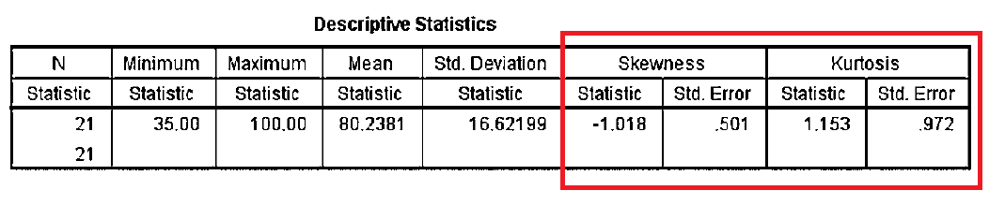
- The z-score for kurtosis (Z_{K})= ______________
- the z-score for skewness (Z_{SK})=____________
- Does this measures indicates that the data has normal distribution? explain your answer

End of the Exam

