Student Name:
Student ID:________________

KING SAUD UNIVERSITY – COLLEGE OF APPLIED MEDICAL SCIENCES
BMT 227 quiz# 1

MICROSOFT POWER POINT - PRACTICAL EXERCISE (A)
(In this exam you would only write in the test paper)

- Fill in the blank with the correct answer:
- Text Box.
- Menu Banner.
- Slide.
- Title Slide.
- Create Slides.

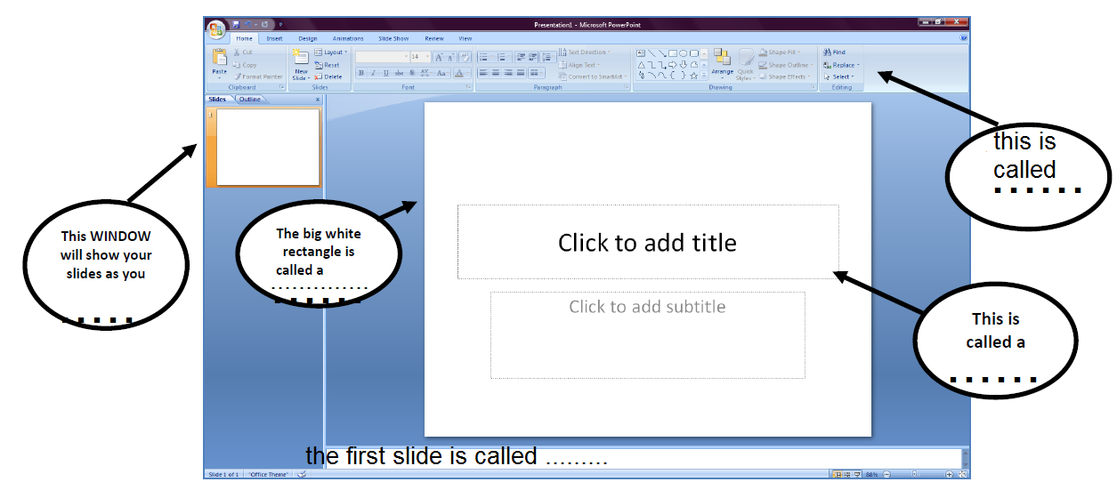

- Choose the correct answer:

- Which of the following should you use if you want all the slide in the presentation to have the same “look”?
- the slide animation option
- add a slide option
- outline view
- a presentation design template

- In the context of animations, what is a trigger?
- An action button that advances to the next slide
- An item on the slide that performs an action when clicked
- The name of a motion path
- All of above

- Special effects used to introduce slides in a presentation are called?
- effects
- custom animations
- transitions
- present animations
- The slide that is used to introduce a topic and the presenter is called the
- table slide
- graph slide
- bullet slide
- title slide

- Which of the following should be used when you want to add a slide to an existing presentation?
- File, add a new slide
- Insert, New slide
- File Open
- File, New

- One of these is NOT one of the three ways to add a picture in a power point slide
- Using a picture on file.
- Using a table.
- Using Clip Art.
- Using Internet Images.

- What you call the following bar?
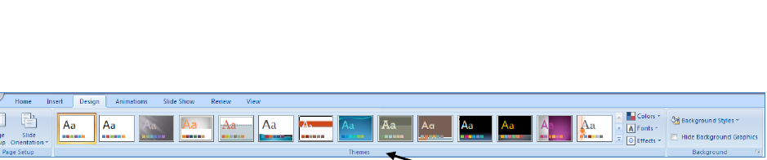

- Theme toolbox.
- Transition.
- Animation,
- Font.

- What is the difference between transition and animation in power point (1)

- Transition is an effect for the slide and animation is for the text.
- Transition is an effect for the text and animation is for the slide.
- Transition is an effect for the font and animation is for the text
- Transition is an effect for the slide and animation is for the layout.

