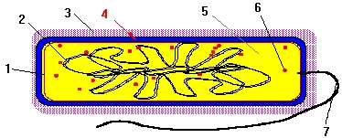

Figure 1

14)The cell component labeled 7 on Figure 1 is the:

a)cell wall
b)flagellum
c)outer membrane
d)chromatin(DNA)
e)ribosome
f)capsule

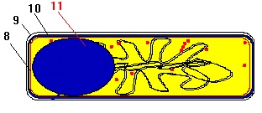

Figure 2

15)The cell component labeled 8 on Figure 2 is the:

a)cell wall
b)flagellum
c)outer membrane
d)chromatin(DNA)
e)cell membrane
f)capsule

16)The cell component labeled 9 on Figure 2 is the:

a)cell wall
b)flagellum
c)outer membrane
d)chromatin(DNA)
e)cell membrane
f)capsule

17)The cell component labeled 10 on Figure 2 is the:

a)cell wall
b)flagellum
c)outer membrane
d)chromatin(DNA)
e)cell membrane
f)capsule

18)The cell component labeled 11 on Figure 2 is the:

a)cell wall
b)flagellum
c)outer membrane
d)chromatin(DNA)
e)endospore
f)capsule

19)Mesosomes are not found in a prokaryotic cell.

True
False

20)The Woese three Domain classifications consist of the bacteria, archaea, and viruses.

True
False

21)Sporulation is initiated by the lack of nutrients in the media.

True
False

22)The copying of RNA from a DNA template is called translation.

True
False

23)Mosaic diseases are so-called because they were first described by Moses in the old Testament.

True
False

24)Reverse Transcriptase is not found in the capsid of the Arenaviridae.

True
False

25)The Marburg agent is a member of the Filoviridae.

True
False

26)The induction of genetic transcription appears to be due to the combination of a repressor
protein on the operator gene of the operon.

True
False

27)In induction of a prokaryotic cell, the operon is in the "off" position because a
repressor gene controls the production of a repressor protein which prevents
transcription of the operon.

True
False

28)The arabinose operon, which is controlled by positive regulation, requires the presence
of arabinose to transcribe and translate its structural genes.

True
False

29)E. coli will only use glucose when presented with a mixture of glucose
and lactose.

True
False

