PROJECT QUALITY PLAN

1. Introduction to the project
Introduction to this project, the quality plan, what are we going to discuss in the document… etc

2. Purpose of Quality Plan for project
الهدف من القيام خطة ضمان الجودة للبرنامج
Describe the Purpose of the quality plan. Why we do it? why is it so important? And why we should adhere to it.

3. Project Scope
وصف وملخص بمهام البرنامج
Describe the project, and the scope of project. What it will do & how it will do it.

4. General Constraints قيود على البرنامج
Constraints on the project that it must adhere to it.
- All scripts shall be written in C# language.

- The data type that should transfer between the system components should be in XML format.

- The System shall run under Linux environment and it should have the ability to transfer later on in Windows 2000 environment.

5. Functional Requirements
1.
2.
3.

6. System and Integration Requirements
[Include information about integration requirements, such as security, output management, deployment issues, infrastructure

- The Employee can access the system from corporate Intranet inside the company if he is authorized.
- The system will also receive event notification if there is any natural disasters occurred from government system.

7. Quality goals
The term “quality goals” refers to the developed software system’s
Quality requirements. (McCall's Quality Factors)

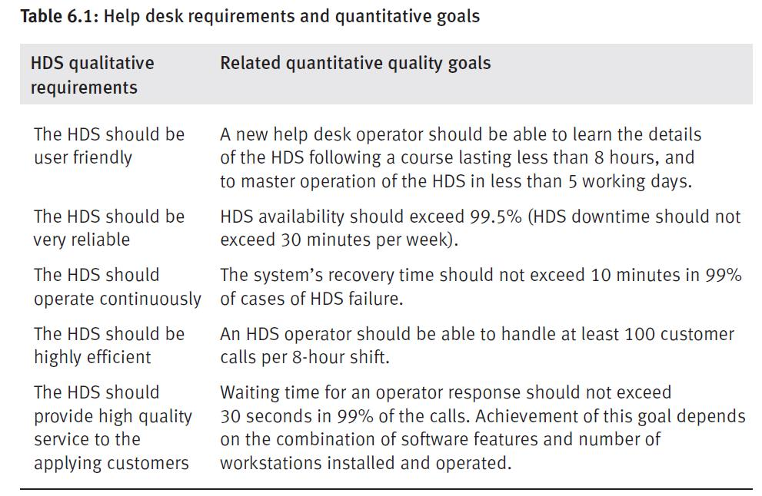

8. Planned Reviews
The quality plan should provide a complete listing of all planned review
activities
- Project Reviews
These are project team work sessions in which the team reviews all deliverables for a phase before scheduling a methodology review.
- Walkthroughs
These are group work sessions in which the walkthrough team validates the deliverable using previously defined scripts, presentations, question & answer sessions, and brainstorming sessions, if appropriate.
- Inspections
These are reviews of a deliverable by the Executive Committee, or sometimes by an implementation team, for the purpose of inspecting and approving the deliverable.

9. Planned Verification Tests
Verification: The process of evaluating software to determine whether the products of a given development phase satisfy the conditions imposed at the start of that phase
#Verification: Are we building the product right?

10. Planned Validation Tests
The process of evaluating software during or at the end of the development process to determine whether it satisfies specified requirements.
#Validation: Are we building the right product?

11. Planned Acceptance Tests
acceptance testing is a test conducted to determine if the requirements of a specification or contract are satisfy the user

12. Planned configuration management.
Software configuration management encompasses the disciplines and techniques of initiating, evaluating, and controlling change to software products during and after the development process.
Software Storage
[what, where, how]
Security and Backups
[what, where, how, how often]
Version Control
[tool, process]

13. Project Team Quality Responsibilities
Describe quality-related responsibilities of the Project Team including specific tasks such as acceptance test, review and configuration management responsibility assignments
Name | Role | Signature | Date

