457 chem. Project
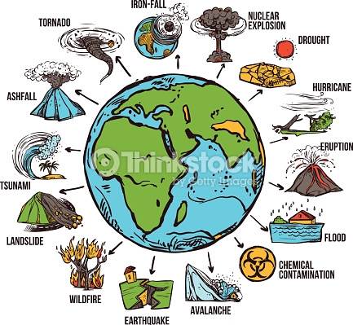
5 marks
Project 1
Topic of interest including but not limited to:
Recent discoveries and inventions in the environmental field, methods to control the damages on the environment, or how to raise awareness on the dangers of abundant use of chemical materials on the environment.
Evaluation will be based upon:
1-Clear presentation and explanation of the information
2- Creativity

