- Create a probably /impact matrix based on the information below. Explain which of the risks needs to be further analyzed and/or watched closely during the project.
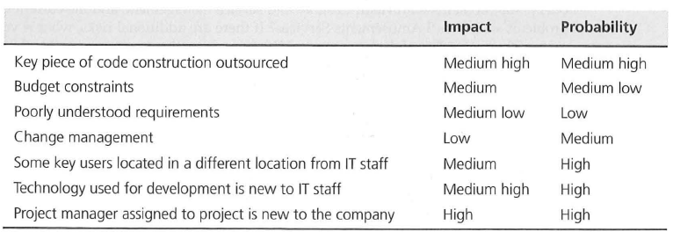

- Following are case study scenarios that represent risk response category choices. Match each scenario with one of the four possible risk responses (accept, avoid, transfer, mitigate) and Explain your answer.

Two critical tasks in the project you are running deal with complex database design issues. You
have negotiated with the supervisor of the data management group to get the group's best worker in this area, John. The problem is that a rumor has surfaced that John is looking for a new job and may leave the company at any time. To make sure your project will be less affected if John leaves, you have built some contingency funds and extra time into the schedule. You have also contacted several local consulting companies that have expertise in database design, just in case.

After researching all the possible software applications on the market, your team has reduced the list to just two choices. The first application delivers on 95 percent of the needed requirements, but the vendor is very new and has a small customer base. The second application
Delivers on 85 percent of the needed requirements; the vendor has been in business for many years and has a large customer base. The company, being risk averse, decides on the second application package.

The current proposed project is to create a custom software application, which will add functionality Identified during the recent gap analysis between the purchased accounting software package and the user requirements. The custom software must interface with the new software, but your orgaI1ization has no one trained in the new software application. The project team has decided to hire a consulting company to develop the new application

