[BCH 322]
The effect of pH on the rate of an enzyme catalyzed reaction
Method:
- Prepare 16 tubes labeled as follows (note: there is a blank for each pH)
  - Blank: (B₃, B₄, B_{4.5}, B₅, B_{5.5}, B₆, B₇, B_{8,} B₉)
  - Test: (T₃, T₄, T_{4.5}, T₅, T_{5.5}, T₆, T₇, T_{8,} T₉)

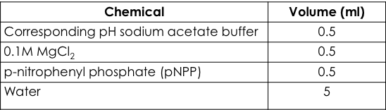
- To each of these tubes add
- Place the tubes in a test tube rack situated in 37ºC water bath and let stand for 5 min.

- Start the reaction by adding 0.5 ml enzyme and stop it by adding 0.5 ml KOH as in the following table:
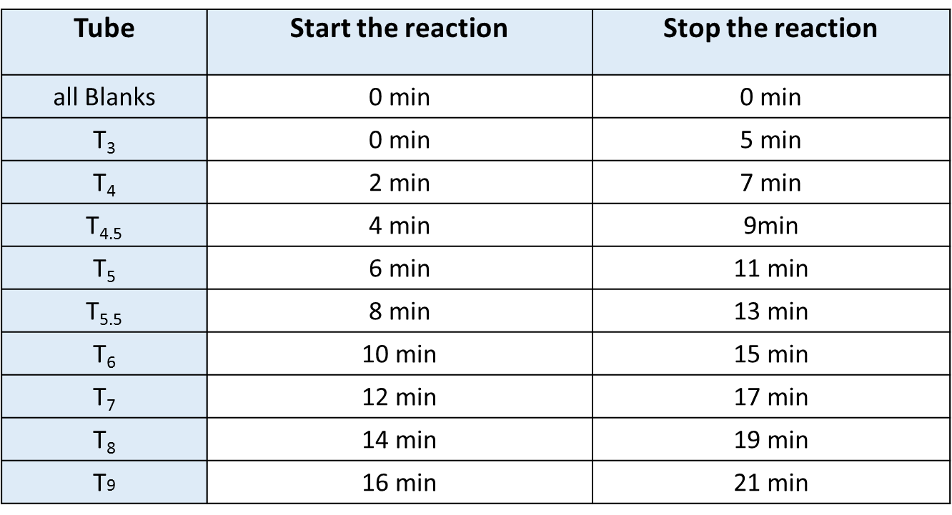
- After all the reactions have been terminated, determine the absorbance at 405 nm for each sample.

Results:
