Oxygen Therapy

Clinical Guidelines:

 Children will receive oxygen therapy as ordered by a healthcare prescriber or as needed in emergency situation for identified respiratory compromise and/or respiratory distress.
 The healthcare prescriber will specify the delivery mode, amount of oxygen in liters per minutes or milliliters per minute, or as the fraction of inspired oxygen (FiO2) as appropriate.
 In the inpatient setting, children receiving oxygen therapy will be monitored by clinical blood gas analysis as ordered by the healthcare prescriber or by continuous or intermittent pulse oximetry to monitor child‘s oxygen saturation levels.
 Selection of the oxygen administration device will be based on the child‘s condition, preference, age, and ability to use a specific device.
 Oxygen may be administered by the use of a nasal cannula, nasopharyngeal catheter, mask, or hood when the oxygen level is below normal or the demand is increased.
 Nasal cannulas and nasopharyngeal catheters are contraindicated in children with nasal obstruction (e.g., nasal polyps and choanal atresia).
 Partial rebreather or non-rebreather masks are not appropriate for use in the neonatal population.
 Restrict the use if ignition sources in child‘s room (e.g., sparking toys, cigarette, candles) when oxygen is in use.
 Secure cylinders of oxygen in upright position.

Indications for Oxygen Administration:
- Hypoxemia documented by invasive or non-invasive assessment.
  - Any one of the following diagnoses or circumstances:

1. Myocardial infarction. | 2. Post anesthesia.
3. Acute anemia. | 4. Post cardiopulmonary or respiratory arrest.
5. Methemoglobinemia. | 6. Reduced cardiac output.
7. Carbon monoxide poisoning. | 8. Hypotension.
9. Cyanosis. | 10. Tachycardia and bradycardia.
11. Dyspnea. | 12. Chest pain.
13. Acute neurological dysfunction. | 14. Severe trauma.

Modes of Oxygen delivery:

Method of delivery | Percentage of oxygen delivered | Liter flow | Nursing care considerations
Nasal Cannula  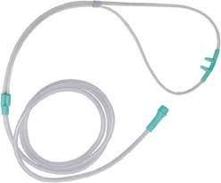 | 21% oxygen plus  3% per liter. | 0.5-6 L/minute | Dries mucosa; give with humidification.  Provides limited oxygen delivery.  Easy to use and well tolerated.  Child can eat and talk without altering FiO2. Contraindicated in children with nasal obstruction.  In newborns and infants flows should be limited to a maximum of 2 L/ minute.  Older children and adolescents can be maintained up to 6 L/minute.
Simple face mask  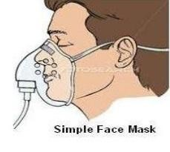 | 35-50% FIO2 | 4-8L/minute | Good for short-term use (e.g.. during procedures. For Transport in emergency situations).  Eating disrupts oxygen delivery.
Partial rebreathing mask  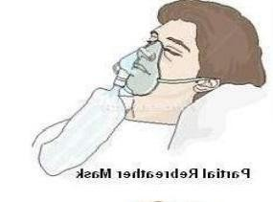 | 40%-60% FIO2 | 6-10 L/minute | Allows greater concentration of oxygen to be delivered.  Eating disrupts oxygen delivery. Not appropriate for neonates.

Non-rebreathing mask  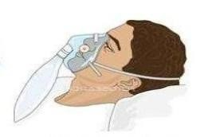 | >60% FIO2 | 6-10 L/minute | Allows greater concentration of oxygen to be delivered.  Eating disrupts oxygen delivery.  Child inhales only from gases in the bag; thus. Kinks in the tubing may cause hypoxia.  Not appropriate for neonates.
Bag valve mask  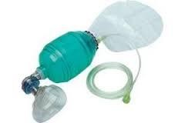 | 65%-95% FIO2 | 10-15  L/minute | Excellent method for assisted ventilation.  Mask is selected to fit over the child's mouth and nose.
Oxygen hood  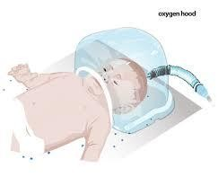 | Can delivered FIO2 up to 100% | 2-  3L/kg/minute | Easy visibility and access to child.  Need to remove infant for feeding and care. Need oxygen analyzer to gauge percentage of the oxygen delivered.  Flows >7 L/minute are required to wash out carbon dioxide.  Temperature in hood needs to be monitored.  High gas flows may produce harmful noise levels.

Assessment:
Assessments should focus on the following:
1-Doctors order for oxygen concentration , method of delivery ,and parameter for regulation(blood gas levels, pulse oximetry values).
2-baseline data: LOC,respiratory status(rate, depth,signs of distress),blood pressure ,and pulse.
3-color of skin and mucous membranes.

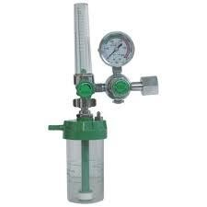
Oxygen therapy procedure:

Equipment's :
- Appropriate –sized oxygen delivery device.
- ―No smoking ― sign.
flowmeter
- Oxygen flowmeter .
- Oxygen tubing.
- Pulse oximeter.
- Paper tape.
- Disposable gloves.
- Goggles (if needed).
- Humidification attachment (if ordered)..
- Humidifier and sterile water.
Nasal Cannula, Mask procedure
Steps | Rationale
1. Perform hand hygiene. Gather all necessary supplies. | ✵ Reduces transmission of microorganisms. Promotes efficient time management and provides an organized approach to the procedure.
2. Select proper size of cannula, or mask. | ✵ Improper sizing of the equipment can lead to nasal obstruction.
3. Remove all friction toys or open flames from the area and display ―no smoking‖ signs. | ✵ Sparks or static electricity will ignite the oxygen.
4. Connect the flowmeter to either the oxygen wall unit or the freestanding tank. | ✵ Allows for the oxygen to flow from source at the prescribed rate.
5. Connect the humidifier to the oxygen setup. | ✵ Provides for moisture in the system. Humidified air is less drying to the nares and the lungs.
6. Following instructions for the particular oxygen setup, fill reservoir with sterile water. | ✵ Use of sterile water decreases the incidence of bacterial growth and mineral buildup within the system.
7. Attach tubing to the oxygen source. | ✵ Allows oxygen to flow from the source to the child.
8. Check all electrical equipment in area to ensure that it is grounded. | ✵ Decreases chance of electrical sparks igniting the  oxygen.
9. Connect the distal end of oxygen tubing to the delivery device (cannula, or mask). | ✵ Completes the cycle of supplying oxygen from the source to the patient.

10. Turn on the flowmeter to the prescribed amount and check to see whether you feel oxygen flowing through the system. | ✵ Verifies that equipment is functioning.
11. Don disposable gloves. lf child is coughing or has copious secretions a mask and goggles may also be worn. | ✵ Gloves and safety equipment protect against transfer of pathogens.
12. Place the child in supine semi-Fowler's position.  Place the infant's head in a midline ―sniffing position. | ✵ Raising the head of the bed helps protect the airway if the child should vomit during airway placement.  Maintains proper alignment of the mouth, pharynx, and trachea.
- A. For nasal cannula:  - Place the nasal prongs just inside the external  meatus of the nares.  - Either loop the head attachment around the child‘s ears and tighten it under the chin or loop it around and behind the head and tighten.  Paper tape or other adhesive materials may be used sparingly to secure the tubing to the face.  - Instruct child to breath through nose. | ✵ Allows the oxygen to flow in proximity to the respiratory system of the child. The means of securing the nasal cannula in place vary on the basis of manufacturer. The result should be the same: a secure nasal cannula. A restless child can easily dislodge the nasal cannula.  Displacement can lead to loss of oxygen delivery. Care should be taken to keep cannula tubing and straps away from the neck to prevent airway obstruction in infants.
Reminder:
- Whatever type of attachment is used, take care to avoid undue pressure on the nasal tissue front tightening the attachment too much.
- Advise parents to watch for redness and irritation at any pressure points.
- Pressure on an area of skin can lead to tissue breakdown.
- Pressure in the nares can cause discomfort and erosion of the mucous membranes of the hares.
- Skin irritation can also occur from local allergic reaction to the polyvinyl chloride content of cannula.
B. For mask:  1. Place the oxygen mask over the mouth and the nose such that the nurse can easily fit one finger between the strap and the child‘s face. | ✵ Properly secured mask allows the prescribed amount of oxygen to flow into the respiratory system.

Child and family evaluation:

  - Evaluate the child / family‘s level of understanding of how and why oxygen therapy is being used.
  - Discuss safety concerns with the family, giving special attention to avoidance of smoking, open flames, and electrical or friction toys.
  - Evaluate the respiratory status of the child.
  - Evaluate child‘s temperature.

Documentation:
  - Document the following:
  - Type of oxygen delivery system that is in use (i.e., cannula, mask, or hood).
  - Time that oxygen therapy was initiated.
  - Setting of the oxygen flowmeter and the frequency and length of time that the hood is open or the oxygen device is not in place
  - Skin status for redness or irritation at pressure points of straps or cannula
  - Child‘s respiratory status.
  - Pulse oximeter reading.

