**Minerals down the microscope**

**Basic optical properties of minerals**

|  |  |
| --- | --- |
| **Analyser out ppl** | **Analyser in xpl** |
| [Colour](http://web2.ges.gla.ac.uk/~minerals/Basic%20Properties.htm#Colour) | [Interference colours](http://web2.ges.gla.ac.uk/~minerals/Basic%20Properties.htm#Interference) |
| [Pleochroism](http://web2.ges.gla.ac.uk/~minerals/Basic%20Properties.htm#Pleochroism) | [Extinction angle](http://web2.ges.gla.ac.uk/~minerals/Basic%20Properties.htm#Extinction) |
| [Shape](http://web2.ges.gla.ac.uk/~minerals/Basic%20Properties.htm#Shape) | [Twinning](http://web2.ges.gla.ac.uk/~minerals/Basic%20Properties.htm#Twinning) |
| [Cleavage](http://web2.ges.gla.ac.uk/~minerals/Basic%20Properties.htm#Cleavage) | [Exsolution](http://web2.ges.gla.ac.uk/~minerals/Basic%20Properties.htm#Exsolution) |
| [Relief](http://web2.ges.gla.ac.uk/~minerals/Basic%20Properties.htm#Relief) | Optic sign & figure |
| [Alteration](http://web2.ges.gla.ac.uk/~minerals/Basic%20Properties.htm#Alteration) |  |

**Properties observed in plane polarized light  
(i.e. with out analyser) p p l الضوء المستقطب السوى**

1. **Colourاللون**

Deeply coloured minerals in hand specimen are likely to be also coloured in thin section, although typically the colour is much stronger in hand specimen than thin section. The more strongly coloured minerals are often relatively Fe-rich or rich other transition metal ions (e.g. Ti, Mn). Hence the colour of a mineral may be quite sensitive to mineral composition. The colour of a mineral is caused by absorption of certain wavelengths of incident white light, the resulting transmitted light lacks these particular wavelengths. Common coloured minerals include: [biotite](http://web2.ges.gla.ac.uk/~minerals/Biotite.htm), [amphibole](http://web2.ges.gla.ac.uk/~minerals/Amphibole.htm), [pyroxene](http://web2.ges.gla.ac.uk/~minerals/Pyroxene.htm)

|  |  |
| --- | --- |
| Analyser out | Analyser out |
| Olive brown biotite | Brown amphibole and green clinopyroxene |
| Olive brown [biotite](http://web2.ges.gla.ac.uk/~minerals/Biotite.htm) | Brown [amphibole](http://web2.ges.gla.ac.uk/~minerals/Amphibole.htm) and green [clinopyroxene](http://web2.ges.gla.ac.uk/~minerals/Pyroxene.htm) |

Opaque minerals do not transmit light and are typically oxides or sulphides and rarely form large proportions of any given rock  
Common opaque minerals include: magnetite, ilmenite, pyrite

|  |  |
| --- | --- |
| Analyser out |  |
| Opaque (Black) magnetite |  |
| Opaque (Black) magnetite |  |

1. **Pleochroismالتغير اللوني**

The mineral is pleochroic if it changes colour when the microscope stage is rotated in plane polarised light (light that has passed through a polaroid sheet to produce light waves that vibrate in only one plane). Pleochroism results from minerals absorbing different wavelengths of light in different crystallographic orientations. Isotropic minerals are uniform in all orientations and do not display pleochroism.Common strongly pleochroic minerals include: [biotite](http://web2.ges.gla.ac.uk/~minerals/Biotite.htm), [amphibole](http://web2.ges.gla.ac.uk/~minerals/Amphibole.htm), [pyroxene](http://web2.ges.gla.ac.uk/~minerals/Pyroxene.htm)

|  |  |
| --- | --- |
| Analyser out | Analyser out (stage rotated by ca. 900) |
| Pale Green | Pale Green Analyser (out) |
| Pale green-blue green pleochroic [amphibole](http://web2.ges.gla.ac.uk/~minerals/Amphibole.htm) |  |

1. **Shape &habit الشكل والهيئة**

The shape, form or habit of a mineral will typically reflect its crystallography, thus sheet silicates tend to form sheets, chain silicates will form elongate or needle-like grains and cubic minerals will typically be equant. This reflects the relative stability of various crystal faces. The shape will also be controlled in part by how easily the mineral is able to grow with an ideal form. Igneous minerals that have grown from a melt will typically be able to form well-shaped (euhedral) crystals, especially if they grow at an early stage during cooling before the rock becomes too crystal rich. Metamorphic crystal growth occurs in the solid state and so crystals will be competing for space with each other. In such instances those with strong (preferred) crystal form tend to be more euhedral. Clastic sedimentary rocks tend to contain broken or rounded grains.  
Common well shaped (euhedral) minerals: Micas ([muscovite](http://web2.ges.gla.ac.uk/~minerals/Muscovite.htm) and [biotite](http://web2.ges.gla.ac.uk/~minerals/Biotite.htm)) = sheets, [Amphibole](http://web2.ges.gla.ac.uk/~minerals/Amphibole.htm) = needles, [Pyroxenes](http://web2.ges.gla.ac.uk/~minerals/Pyroxene.htm) = Prisms, [Garnet](http://web2.ges.gla.ac.uk/~minerals/Garnet.htm) = equant

Common poorly shaped (anhedral) minerals: [Calcite](http://web2.ges.gla.ac.uk/~minerals/Calcite.htm), [Quartz](http://web2.ges.gla.ac.uk/~minerals/Quartz.htm), [Plagioclase](http://web2.ges.gla.ac.uk/~minerals/Plagioclase.htm)

|  |  |
| --- | --- |
| Analyser out | Analyser in |
| Euhedral muscovite in Quartz mix | Anhedral quartz in gaps between euhedral plagioclase and amphibole |
| Euhedral [muscovite](http://web2.ges.gla.ac.uk/~minerals/Muscovite.htm) in quartz matrix | Anhedral [quartz](http://web2.ges.gla.ac.uk/~minerals/Quartz.htm) in gaps between euhedral [plagioclase](http://web2.ges.gla.ac.uk/~minerals/Plagioclase.htm) and [amphibole](http://web2.ges.gla.ac.uk/~minerals/Amphibole.htm) |

1. **Cleavageالانفصام**

Cleavage will appear as sets of parallel lines in thin sections. Cleavage is an ability of the mineral to crack along well-defined crystallographic planes within the lattice structure. Hence cleavage planes are frequently oriented parallel to crystal faces and edges of euhedral crystals. Sheet silicates (e.g. micas; [muscovite](http://web2.ges.gla.ac.uk/~minerals/Muscovite.htm) and [biotite](http://web2.ges.gla.ac.uk/~minerals/Biotite.htm)) tend to have one excellent cleavage, chain silicates (e.g. [amphiboles](http://web2.ges.gla.ac.uk/~minerals/Amphibole.htm) and [pyroxenes](http://web2.ges.gla.ac.uk/~minerals/Pyroxene.htm)) have two cleavages and framework silicates (e.g.feldspars; [plagioclase](http://web2.ges.gla.ac.uk/~minerals/Plagioclase.htm) and [K-Feldspar](http://web2.ges.gla.ac.uk/~minerals/K-Feldspar.htm)) and carbonates (e.g. [calcite](http://web2.ges.gla.ac.uk/~minerals/Calcite.htm)) often have three cleavages. Not all individual crystals will display cleavage (depending on the orientation of the crystal) and the quality of the cleavage. Micas have one excellent cleavage but this will not be seen when the thin section is cut parallel to the orientation of the sheets, similarly elongate sections of amphibole will typically only show one cleavage. Minerals with relatively poor cleavage, such as feldspars, often will display cleavage best towards the edge of a thin section where the rock is typically a little more fractured during the production of the thin section.

|  |  |
| --- | --- |
| Analyser out | Analyser out |
| Cleavage traces in calcite | Cleaved amphibole and pyroxenes |
| Cleavage traces in [calcite](http://web2.ges.gla.ac.uk/~minerals/Calcite.htm) | Cleaved [amphibole](http://web2.ges.gla.ac.uk/~minerals/Amphibole.htm) and [pyroxenes](http://web2.ges.gla.ac.uk/~minerals/Pyroxene.htm) |

1. **Reliefالتضاريس**

Common high relief minerals: [Garnet](http://web2.ges.gla.ac.uk/~minerals/Garnet.htm)  
Common low relief minerals: [Quartz](http://web2.ges.gla.ac.uk/~minerals/Quartz.htm), [Plagioclase](http://web2.ges.gla.ac.uk/~minerals/Plagioclase.htm), [K-Feldspar](http://web2.ges.gla.ac.uk/~minerals/K-Feldspar.htm)  
Some minerals (e.g. [calcite](http://web2.ges.gla.ac.uk/~minerals/Calcite.htm)) transmit light at different speeds depending on the orientation of the crystal lattice. Thus relief changes when the microscope stage is rotated.

|  |  |
| --- | --- |
| High relief garnet,moderate relief biotite and low relief quartzAnalyser out |  |
| High relief [garnet](http://web2.ges.gla.ac.uk/~minerals/Garnet.htm), moderate relief [biotite](http://web2.ges.gla.ac.uk/~minerals/Biotite.htm) and low relief [quartz](http://web2.ges.gla.ac.uk/~minerals/Quartz.htm) |  |
|  |  |

1. **Alterationالتحلل**

Common minerals that form at high temperatures: [Olivine](http://web2.ges.gla.ac.uk/~minerals/Olivine.htm), [Pyroxene](http://web2.ges.gla.ac.uk/~minerals/Pyroxene.htm), [Amphibole](http://web2.ges.gla.ac.uk/~minerals/Amphibole.htm), [Biotite](http://web2.ges.gla.ac.uk/~minerals/Biotite.htm), [Garnet](http://web2.ges.gla.ac.uk/~minerals/Garnet.htm) Common minerals that form as alteration products: [Chlorite](http://web2.ges.gla.ac.uk/~minerals/Chlorite.htm), [Muscovite](http://web2.ges.gla.ac.uk/~minerals/Muscovite.htm), Clay minerals

|  |  |
| --- | --- |
| Analyser out | Analyser in |
| Rim of amphibole alteration around original pyroxene | Sericite (fine grained white mica/clays) alteration of plagioclase |
| Rim of [amphibole](http://web2.ges.gla.ac.uk/~minerals/Amphibole.htm) alteration around original [pyroxene](http://web2.ges.gla.ac.uk/~minerals/Pyroxene.htm) | Sericite (fine grained white [mica](http://web2.ges.gla.ac.uk/~minerals/Muscovite.htm)/clays) alteration of [plagioclase](http://web2.ges.gla.ac.uk/~minerals/Plagioclase.htm) |

**Properties observed in crossed polar xpl  
(i.e. with analyzer in)**

1. **Interference colors**

Irrespective of their orientation some minerals go dark when the analyser is inserted and remain dark when the microscope stage is rotated. Such minerals are isotropic.  
Common **isotropic** minerals are: [Garnet](http://web2.ges.gla.ac.uk/~minerals/Garnet.htm)  
Other minerals may remain dark if the thin section is cut in a particular orientation (e.g. [Biotite](http://web2.ges.gla.ac.uk/~minerals/Biotite.htm) cut parallel to it’s cleavage plane)  
**The colours that a mineral shows in thin section with the analyser in are called interference colours**. These vary according to orientation of the crystal and the thickness of the thin section. minerals show either low order interference colours (grey-white-yellow), moderate interference colours (red-blue-green-yellow-red), high order interference colours (pinks and greens, with very high order colours these tend to merge to produce a golden colour). All minerals will display a range of interference colours, it is the maximum order displayed that is distinctive.  
Interference colours (image from www.mindat.org)

|  |  |  |
| --- | --- | --- |
| Interference colours | | |
| Low | Moderate | High |

Common minerals with low order interference colours: [Quartz](http://web2.ges.gla.ac.uk/~minerals/Quartz.htm), [Plagioclase](http://web2.ges.gla.ac.uk/~minerals/Plagioclase.htm), [K-Feldspar](http://web2.ges.gla.ac.uk/~minerals/K-Feldspar.htm), [Chlorite](http://web2.ges.gla.ac.uk/~minerals/Chlorite.htm)  
Common minerals with moderate order interference colours: [Amphiboles](http://web2.ges.gla.ac.uk/~minerals/Amphibole.htm), [Pyroxenes](http://web2.ges.gla.ac.uk/~minerals/Pyroxene.htm)  
Common minerals with moderate-high order interference colours: [Muscovite](http://web2.ges.gla.ac.uk/~minerals/Muscovite.htm), [Biotite](http://web2.ges.gla.ac.uk/~minerals/Biotite.htm), [Olivine](http://web2.ges.gla.ac.uk/~minerals/Olivine.htm)  
Common minerals with very high order interference colours: [Calcite](http://web2.ges.gla.ac.uk/~minerals/Calcite.htm)

|  |  |
| --- | --- |
| Analyser in | Analyser in |
| Low order interference colours (quartz) | Moderate order interference colours (olivine and clinopyroxene) Note: range of colours in small area of the pyroxene where the mineral thins towards a small hole |
| Low order interference colours ([quartz](http://web2.ges.gla.ac.uk/~minerals/Quartz.htm)) | Moderate order interference colours ([olivine](http://web2.ges.gla.ac.uk/~minerals/Olivine.htm) and [clinopyroxene](http://web2.ges.gla.ac.uk/~minerals/Pyroxene.htm)) Note: range of colours in small area of the pyroxene where the  mineral thins towards a small hole. |
| Analyser in |  |
| Very high order interference colours (calcite) |  |
| Very high order interference colours ([calcite](http://web2.ges.gla.ac.uk/~minerals/Calcite.htm)) |  |

1. **Extinction angle**

On rotation of the microscope stage minerals that are not isotropic will become dark in one particular orientation, such minerals are said to be in extinction. Frequently minerals may have a prominent [cleavage](http://web2.ges.gla.ac.uk/~minerals/Basic%20Properties.htm#Cleavage) or planer crystal boundary that allows measurement the angle between the orientation of the mineral in extinction position and the orientation of the mineral lattice (e.g. cleavage). Some minerals have **straight extinction** or **parallel** (i.e. when the cleavage or crystal face is oriented either N-S or E-W the mineral is in extinction), others have **inclined extinction** (i.e. the mineral is in extinction when the crystal lattice in inclined relative to N-S or E-W cross-hairs)..  
**Common minerals with straight extinction:** [**Biotite**](http://web2.ges.gla.ac.uk/~minerals/Biotite.htm)**,** [**Muscovite**](http://web2.ges.gla.ac.uk/~minerals/Muscovite.htm) **Common minerals with inclined extiction:** [**Amphiboles**](http://web2.ges.gla.ac.uk/~minerals/Amphibole.htm) **(typically low angles of extinction <25o),** [**Clinopyroxene**](http://web2.ges.gla.ac.uk/~minerals/Pyroxene.htm) **(typically high angles of extinction >25o)**Extinction angles can only be measured relative to planer crystal boundaries or cleavage planes.

|  |  |
| --- | --- |
| Analyser in | Analyser in |
| Inclined extinction wrt cleavage in Clinopyroxene | Inclined extinction wrt amphibole shape and cleavage |
| Inclined extinction wrt [cleavage](http://web2.ges.gla.ac.uk/~minerals/Basic%20Properties.htm#Cleavage) in Clinopyroxene | Inclined extinction wrt [amphibole](http://web2.ges.gla.ac.uk/~minerals/Amphibole.htm) [shape](http://web2.ges.gla.ac.uk/~minerals/Basic%20Properties.htm#Shape) and [cleavage](http://web2.ges.gla.ac.uk/~minerals/Basic%20Properties.htm#Cleavage) |
| Analyser out | Analyser in |
| Straight Extiction (analyser out) | Straight extinction (analyser in) |
| Straight extinction in [muscovite](http://web2.ges.gla.ac.uk/~minerals/Muscovite.htm) grain with [cleavage](http://web2.ges.gla.ac.uk/~minerals/Basic%20Properties.htm#Cleavage) in E-W orientation  (top of field of view) | |

1. **Twinning**

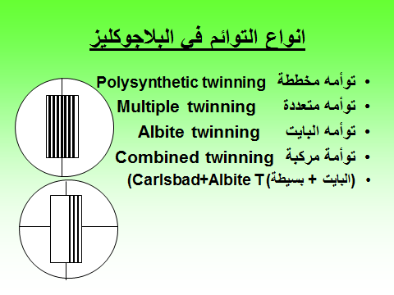Twinning is recognised by adjacent portions of a single crystal having different extinction positions (i.e. different crystallographic orientations). Twinning is most easily observed with crossed polar. Twins are typically separated by planer boundaries across which crystals show different interference [colours](http://web2.ges.gla.ac.uk/~minerals/Basic%20Properties.htm#Interference). Twinning may take a variety of different forms and is particularly common and distinctive in the feldspars ([plagioclase](http://web2.ges.gla.ac.uk/~minerals/Plagioclase.htm) and [K-Feldspar](http://web2.ges.gla.ac.uk/~minerals/K-Feldspar.htm)). **Multiple twins in** [**plagioclase**](http://web2.ges.gla.ac.uk/~minerals/Plagioclase.htm)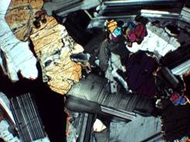

|  |  |
| --- | --- |
| Analyser in |  |
|  |  |
|  |  |

1. **Exsolution**

.. Such exsolution textures are most readily observed in cross polars as host and exsolved minerals often have rather similar optical properties and so may have similar [relief](http://web2.ges.gla.ac.uk/~minerals/Basic%20Properties.htm#Relief). Common minerals that show exsolution textures: Feldspars ([plagioclase](http://web2.ges.gla.ac.uk/~minerals/Plagioclase.htm) and [K-feldspar](http://web2.ges.gla.ac.uk/~minerals/K-Feldspar.htm)), [Pyroxene](http://web2.ges.gla.ac.uk/~minerals/Pyroxene.htm) (clinopyroxene and orthopyroxene).

|  |  |
| --- | --- |
| Analyser in | Analyser in |
| K-feldspar host with exsolved fine network of plagioclase | Orthopyroxene host with exsolved clinopyroxene |
| K-feldspar host with exsolved fine network of [plagioclase](http://web2.ges.gla.ac.uk/~minerals/Plagioclase.htm) | Orthopyroxene host with exsolved clinopyroxene |

**Optical sign and figures** ( high lenses(blue )+analyzer in+ Bertrand lenses in)

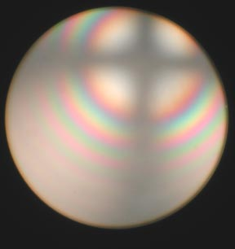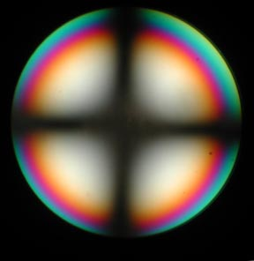

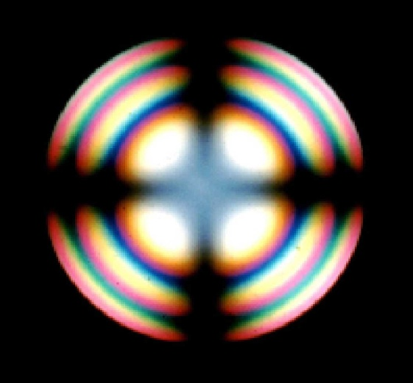

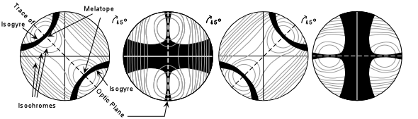

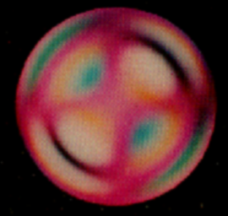

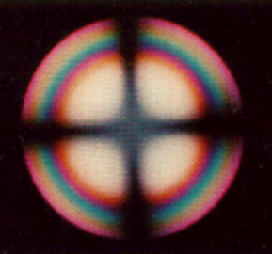

Blue in NW is (-)

With plate without plate

Geology dep.

Geo 221

Minerals Optical properties chart

PPL PLANE POLAREZED LIGHT

Without analyzer

Color

**Isotropic mineralISOTROPSIM**

Crystal form &Crystal habit

Pleochrosim

Cleavage

Relief

Extinction

With analyzer C.O CROSS NICOLES XPL

Twinning

Interference color

Optical figure

Optical sign

Nomenclature (GROUP, NAME)

PPL XPL