HECS 5621M
Principles for Medical Imaging Interpretation

Liver Cirrhosis:
Progression using Ultrasound

Date: 30 /4/2012
Word Count: 1612
Student ID: 200579659

“I confirm that this submission is my own work and that I have not presented anyone else’s work as my own, and that full and appropriate acknowledgement has been given where reference has been made to the work of others. I have read and understood the University’s published rules on plagiarism and also any rules specified at School/Faculty level. I understand that if I commit plagiarism I can be expelled from the University and that it is my responsibility to be aware of the University’s regulations on plagiarism and their importance.”
Introduction:
Cirrhosis is a disease that affects the liver causing scaring, fibrosis and eventually, deterioration of liver function. Healthy liver parenchyma is gradually replaced by scared fibrotic tissue that progressively diminishes blood flow to liver cells which on the long run results in liver failure. It generally results from long term liver damage that may be caused by several factors the most common being: Hepatitis C, B virus and increase alcohol consumption. Cirrhosis is usually an irreversible disease and treatment consists of reducing symptoms and minimising progression. Liver cirrhosis may also develop into hepatocellular carcinoma, this occurs in 80% of the cases (Pinzani et al.,20011). In late stages, as the liver ceases to function, the single alternative is liver transplant. This paper will focus on describing the progression of liver cirrhosis using ultrasound as a diagnostic tool, as it proves advantageous over other modalities such as Computed Tomography and Magnetic resonance imaging.

Why Ultrasound?
Liver cirrhosis is difficult to diagnose in its early stages due to the nonspecific findings at this stage. According to Schuppan and Afdhal (2008) and Ibrahim et al. (2011), MRI, C.T and ultrasound are not sensitive enough for the detection of early liver cirrhosis. The gold standard for diagnosing liver cirrhosis is liver biopsy. However, biopsy has its disadvantages such as the number of false negatives due to insufficient samples and being an invasive procedure (Berzigottiet al.,2010). Nicolau (2002), points out that early stages may merely include enlarged liver with fatty deposits (fatty liver). Although ultrasound may not be very sensitive in detecting cirrhosis itself, it does provides good soft tissue contrast which can differentiate a normal liver from a fatty one by comparing the echogenicity of the liver with the adjacent right kidney (Gaiani et al.,1997). Ultrasound is also useful in detecting liver surface nodularities and irregularities especially using high frequency transducers (Nicolau et al.,2002). Abnormal fluid collections such as ascites are easily distinguished due to the increased transmission of sound waves through fluids which appear anechoic areas on the image. In cases of portal hypertension that results from cirrhosis, colour Doppler is very accurate in determining the direction of blood flow in the portal and hepatic veins and pulsed doppler measures the velocity of blood in the hepatic and portal veins to calculate hepatic venous pressure gradients (Wu,2008). The introduction of contrast enhanced ultrasound and elastography have increased the diagnostic accuracy of ultrasound in detecting liver nodules due to cirrhosis. In fact, Pompili et al (2007) reported very good concordance between contrast-enhanced ultrasound and multi-detector C.T. The diagnostic accuracy of contrast enhanced ultrasound in detecting focal lesions in the liver has been found to be 96.6% (Goyal et al.,2009). Furthermore, the most important factors that make ultrasound the first choice of imaging is that it is non-ionizing, non-invasive, inexpensive, fast and is available and repeatable (Nicolau et al.,2002).

Other modalities:
Even though MRI, CT and Ultrasound are not very sensitive it detecting early stages of cirrhosis, their specificity is high (Schuppan and Afdhal,2008). They are sensitive in detecting complications of cirrhosis such as splenomegaly, ascites, shrunken nodular surface of the right lobe, hypertrophy of the left or caudate lobe, collateral vessels and varices. However, MRI is slightly more sensitive than C.T and ultrasound in detecting hepatocellular carcinoma that may occur from cirrhosis. Appearance on MRI is almost the same as ultrasound see Appendix (1).
Normal appearance:
The normal liver is around 15-16 cm long and has uniform texture and homogenous echogenicity throughout the parenchyma, with a smooth surface, regular borders and outline with the anechoic hepatic and portal veins running through the parenchyma. Liver echogenicity should be slightly higher than the kidney. Normal liver parenchyma is interrupted by the gallbladder and the billiary system. The gallbladder wall should not exceed 3mm thick. No fluid or collection should be seen around the liver. Direction of flow in the portal vein should be hepatopetal (towards liver) (Goyal et al.,2009).
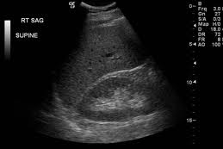
Diaphragm
Normal liver echogenisity
Normal size liver with uniform homogenous texture
Normal kidney
No free fluid or ascites around the liver or in the hepatorenal space
Smooth regular outline of the liver
Fig (1) Normal liver compared with right kidney (Radrounds.com, 2012)

Early stage:
In early stages of liver cirrhosis, there may not be much change in appearance. Some of the findings in early stages are that the liver usually becomes enlarged (> 15cm) and its echogenicity increases due to the fatty deposits in the parenchyma. However, its border, outline and surface usually are not obliterated. No fluid collection is seen in early stages. Course liver texture may be noted in cases of cirrhosis due to hepatitis (Denzer et al.,2009).
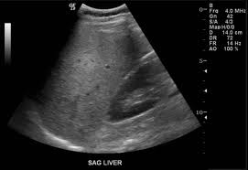
Liver still retains its smooth regular outline
Increased echogenicity of liver compared to kidney
No free fluid or ascites around liver
Enlarged liver exceeding tip of kidney
Fig (2)Enlarged fatty liver compared to the right kidney(Dietforfattyliver.net, 2011)
Late stage:
As cirrhosis progresses, normal liver parenchyma becomes replaced with fibrous tissue and regenerative nodules which lead to increase in portal pressure and portal hypertension. Portal hypertension results in splenomegaly (Spleen size > 12cm), collateral vessels and varices that may be seen around the spleen. The diameter of portal vein usually increases in size. The right lobe of the liver gradually shrinks while the left lobe or sometimes the caudate lobe enlarges (Denzer et al.,2009). In addition, liver texture becomes coarse and heterogeneous (Nicolau et al.,2002). As the liver function decreases, fluid starts to accumulate in the abdomen (ascites) and due to the replacement of normal liver tissue with regenerative nodular and fibrous tissue, the liver surface and outline becomes nodular and irregular. Portal vein walls become less defined and the hepatic vein borders become irregular (Nicolau et al.,2002). Often, cirrhosis is accompanied with thickening of the gallbladder wall with or without gallstones. This appears very clear on ultrasound, as it is the most reliable modality for detecting gallstones (Gaiani et al.,1997). However, unlike MRI or CT, ultrasound cannot demonstrate all the pathological findings in one image, as multiple images and scanning planes must be used to detect different pathologies such as splenomegaly, varices, thickened gallbladder wall and dilated portal vein. Another ultrasound limitation is that it is highly operator dependent.
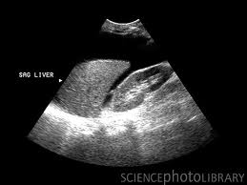
Free fluid and ascites around the liver and in the hepatorenal space
Irregular nodular surface of liver
Course heterogeneous liver texture
Liver shrunken in size compared to the kidney
Fig (3) Shrunken nodular right lobe of liver with ascites (sciencephoto.com, 2011)

Differential diagnosis:
Findings of liver cirrhosis can mimic other diseases, for example ascites can be caused by several factors including cirrhosis, malignancies, tuberculous peritonitis and congestive heart failure (Medscape, Cirrhosis,2011). However, ascites in addition to a shrunken nodular surface of the right lobe of liver and enlargement of the left or caudate lobe is almost always consistent with cirrhosis. Budd-Chiari syndrome is another differential diagnosis that is difficult to distinguish from cirrhosis, as it also results in portal hypertention and ascites. Nevertheless, Budd-Chiari can be ruled out by performing an ultrasound Doppler scan to assess hepatic and portal vein patency. Alternatively, an abdominal MRI with contrast may also be performed (Schuppan and Afdhal,2008).
Conclusion:
In conclusion, although ultrasound is not the most sensitive modality to image liver lesions that may be caused by cirrhosis, it is still used as the first line of imaging as it provides a cost effective, non-ionizing quick and sensitive method of detecting complications of cirrhosis such as liver surface irregularity and nodularity, shrunken right lobe, enlarged left or caudate lobe, splenomegaly, ascites, varices and collateral veins. New techniques such as contrast enhanced ultrasound and ultrasound elastography have improved the diagnostic accuracy of ultrasound as a diagnostic tool in general and in liver cirrhosis particularly.

References:
- BERZIGOTTI, A., J. ABRALDES, P. TANDON, E. ERICE, R. GILBERT, J GARCIA-PAGAN, J. BOSCH, 2010. Ultrasonographic evaluation of the liver surface and transient elastography in clinically doubtful cirrhosis. Journal of Hepatology. 52, pp 846-853.
- DENZER, U., S. LÜTH, 2009. Non-invasive diagnosis and monitoring of liver fibrosis and cirrhosis. Journal of Best Practice & Research Clinical Gastroenterology. 23, pp 453-460.
- GAIANI, S., L. GRAMANTIERI, N. VENTUROLI, F. PISCAGLA, S. SIRINGO, A. DʼERRICO, G. ZIRONI, W. GRIGIONI, L. BOLONDI, 1997. What is the criterion for differentiating chronic hepatitis from compensated cirrhosis? A prospective study comparing ultrasonography and percutaneous liver biopsy. Journal of Hepatology. 27, pp 979-985.
- GOYL, N., N. JAIN, V. RACHAPALLI, D. COCHLIN, M. ROBINSON, 2009. Non-invasive evaluation of liver cirrhosis using ultrasound. Journal of clinical Radiology. 64, pp 1056-1066.
- IBRAHIM, H., A. EL-HAMID, A. TOHAMY, M. HABBA, 2011. Diagnostic value of apparent diffusion coefficient calculated with diffusion-weighted MRI for quantification of liver fibrosis. The Egyptian Journal of Radiology and Nuclear Medicine. 42, pp 119-131.
- MEDSCAPE, 2011. Cirrhosis: Definition, Epidemiology and Etiology of Cirrhosis. [Accessed on 1 March 2012] Available at http://www.emedicine.medscape.com/article/185856-overview.
- NICOLAU, C., L. BIANCHI, R. VILANA, 2002. Gray-Scale Ultrasound in Hepatic Cirrhosis and Chronic Hepatitis: Diagnosis, Screening and Intervention. Seminars in Ultrasound, C.T and MRI, 23(1), pp 3-18.
- PINZANI, M., M. ROSSELLI, M. ZUCKERMANN, 2011. Liver cirrhosis. Journal of Best Practice & Research Clinical Gastroenterology. 25, pp 281-290.
- POMPILI, M., L. RICCARDI, S. SEMERARO, R. OREFICE, F. ELIA, B. BARBARO, M. COVINO, A. GRIECO, G. GASBARRINI, G. RAPACCINI, 2008. Journal or Digestive and Liver Disease. 40, pp 206-215.
- SCHUPPAN, D., N. AFDHAL. 2008. Liver cirrhosis. The Lancet. 371, pp 838-851.
- WU, C., 2008. Ultrasound Evaluation of Portal Hypertension and Liver Cirrhosis. Journal of Medical Ultrasound. 16(6), pp188-193.
Appendex:
Appendex (1)

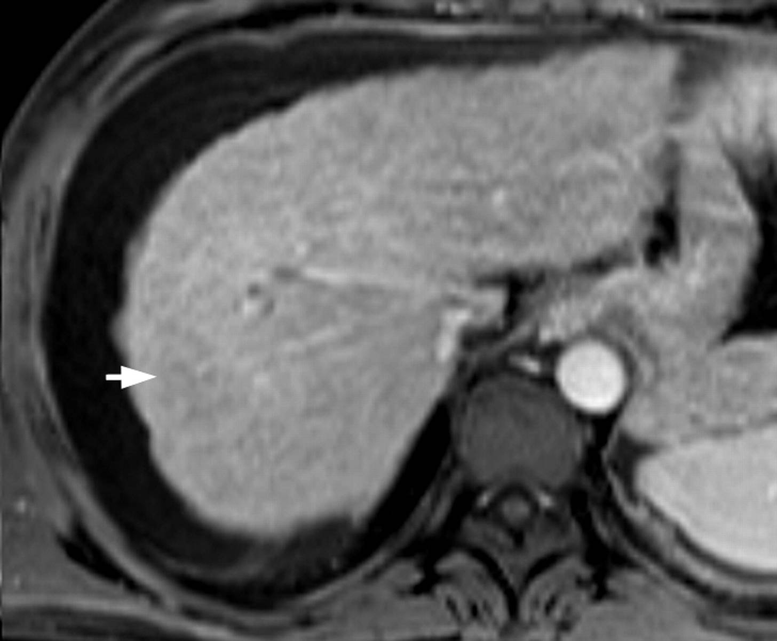
Pancreas
Aorta
Tip of enlarged spleen
Irregular and nodular outline of liver
Free fluid and ascites around the liver
Fig (4) MRI image of abdomen showing irregular liver surface, ascites and enlarged spleen, signs of liver cirrhosis
.

