Microsoft Excel
Multiple Choice Question and Answers

a. When integrating Word and Excel, Word is usually the
a. Server
b. Client
c. Source
d. None of these
Correct answer:
ans2
Explanation:
When integrating Word and Excel, Word is usually the client because Excel serves the data and word uses these data in document. A consumer of service is client and producer of service is server.

b. The number of rows in a worksheet is
a. 36500
b. 65536
c. 256
d. 64536
Correct answer:
ans2
Explanation:
An worksheet consists 256 columns and 65536 rows.
c. When a formatted number does not fit within a cell, it displays
a. #####
b. #DIV/0
c. #DIV@
d. None of these
Correct answer:
ans1
Explanation:
If a formatted number does not fit within a cell it displays #####. Similarly, if unformatted number does not fit, it displays the number in scientific format.
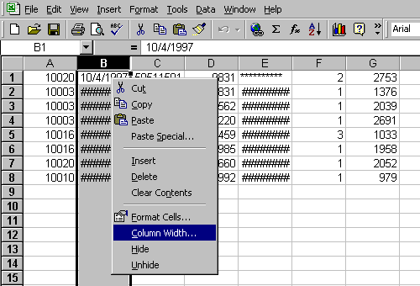

d. What symbol is used to enter number as text?
a. ‘
b. ”
c. =
d. +
Correct answer:
ans1
Explanation:
A number is entered preeceding by a single quote (‘) to enter it as label.

e. Data can be arranged in ascending or descending order by using
a. Sort command from Table menu
b. Sort command from Data menu
c. Sort command from Tools menu
d. None of these
Correct answer:
ans2
Explanation:
You can access Data >> Sort menu to arrange data in ascending or descending order.

f. Which of the following is concantenating operator?
a. Apostrophe (‘)
b. Exclamation (!)
c. Ampersand (&)
d. Hash (#)
Correct answer:
ans3
Explanation:
Ampersand (&) can be used to concantenate text in excel.
This is one of those questions that you can never find in Excel help, because no one thinks to search for the word “Concatenation”. Heck, I don’t think any normal person ever uses the word concatenate. If you don’t know to search for Concatenate, then you will never learn that the concatenation operator is an ampersand. Start with a basic formula of
=A2&B2
Read this tutorial

g. Red triangle at the top right corner of a cell indicates
a. There is an error in the cell
b. There is a comment associated with the cell
c. The font color of the text in cell is red
d. The cell can’t accept formula
Correct answer:
ans2
Explanation:
A red triangle at the top right corner of cell indicates a comment associated. If you place mouse point over the triangle it will show the comment typed.
h. To select multiple non-adjecent cells in a worksheet you will click them holding
a. CTRL key
b. ALT key
c. Shift Key
d. Ctrl+Shift key
Correct answer:
ans1
Explanation:
Holding Ctrl and clicking cells will allow you to select multiple cells that are not joined with each other.
Following is the image of cells selected holding ctrl
i. Cell E23 has a date value and you wish to place that date on an invoice prefaced with the text located in B15. What is the command to do that?
a. =B15&E23
b. =proper(B15)&” “&text(E23,”mmmm dd, yyyy”)
c. B15&” “&E23
d. =join(B15&E23)
Correct answer:
ans2
Explanation:
=proper(B15)&” “&text(E23,”mmmm dd, yyyy”) is the correct answer.
=proper() will convert text into proper case. & will join the text. ” ” will insert an empty space. text() function will convert the value in cell into text in given format.
Other options won’t provide desired output.

j. How many sheets are there in Excel Workbook by default?
a. 2
b. 3
c. 4
d. 5
Correct answer:
ans2
Explanation:
There are 3 worksheets in a workbook by default.

k. Which of the following component displays the contents of active cell?
a. Name box
b. Formula bar
c. Menu bar
d. Status bar
Correct answer:
ans2
Explanation:
Formula bar displays the contents of active cell.

l. To move to the previous worksheet press
a. Ctrl+PgUp
b. Ctrl+PgDn
c. Shift+Tab
d. Ctrl+Tab
Correct answer:
ans1
Explanation:
Ctrl+PgUp moves to the previous worksheet. Similarly Ctrl+PgDn moves to the next.

m. The accounting style shows negative numbers in
a. Bold
b. Brackets
c. Paranthesis
d. Quotes
Correct answer:
ans3
Explanation:
Accounting style shows negative numbers in paranthesis.

n. The process of identifying specific rows and columns so that so that certain columns and rows are always visible on the screen is called
a. freezing
b. locking
c. selecting
d. fixing
Correct answer:
ans1
Explanation:
When you freeze panes you can fix specified rows and columns so that they are always visible on the screen. So, freezing is the correct answer.

o. When you create two or four separate windows containing part of the spreadsheet that can be viewed, you have created
a. sections
b. panes
c. views
d. subsheets
Correct answer:
ans2
Explanation:
If you split window into two or four parts you have created panes. The concept of Sections, views and subsheets do not exist in Excel.
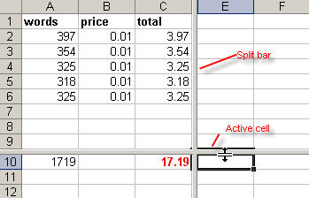

p. To keep specific rows and columns from scrolling off the screen you first must position the cell pointer
a. to the right of the column you want to remain on the screen
b. below the row you want to remain on the screen
c. on the row you want to remain on the screen
d. both below and right of the row and column you want to remain on the screen
Correct answer:
ans4
Explanation:
To freeze some rows and columns you need to position cell pointer below the rows and right of the columns you want them to freeze. Excel will draw freeze line on the top and left edge of active cell.
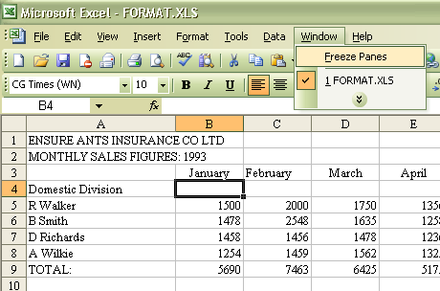

q. If you wanted to sort an employee file so that they would be listed alphabetically by last name and first name within individual zip codes (smallest to largest), which of the following would be the correct order of the sort?
a. zip codes (ascending), then last name (ascending), then first name (ascending)
b. last name (ascending), then first name(ascending), then last name (ascending)
c. zip codes (descending), then last name(ascending), then first name(ascending)
d. last name (descending), then first name (descending), then last name (descending)
Correct answer:
ans1
Explanation:
Because the list should be arranged alphabetically from smallest to largest within individual zip codes they should be sorted by zip codes (ascending) then by last name and then first name all ascending.

r. If you require more than two conditions or if you want to analyze a list using Excel 2003′s database functions, you must define which filter?
a. Auto Filter
b. Update Filter
c. Advantage Filter
d. Advanced Criteria Filter
Correct answer:
ans4
Explanation:
You can filter using Advanced Criteria Filter if more than two conditions should be tested.

s. A quick way to return to a specific area of a worksheet is to type in the _____
a. Name box
b. Formula bar
c. Zoom box
d. None of these
Correct answer:
ans1
Explanation:
You can type the cell address or range name in Name box to return to a specific area of a worksheet.

t. Which keyboard shortcut opens the Go To dialog box?
a. Ctrl + B
b. Ctrl + Shift + B
c. F2
d. F5
Correct answer:
ans4
Explanation:
Pressing F5 key brings the Goto Dialog box.

