Name; Manal Moman Morshed
Name of Time series : w12.1
Time series plot :

The Autocorrelation and the partial Autocorrelation:
The Model is AR(1) and Ø > 0

The Autocorrelation and the partial Autocorrelation of riesedual equal zero
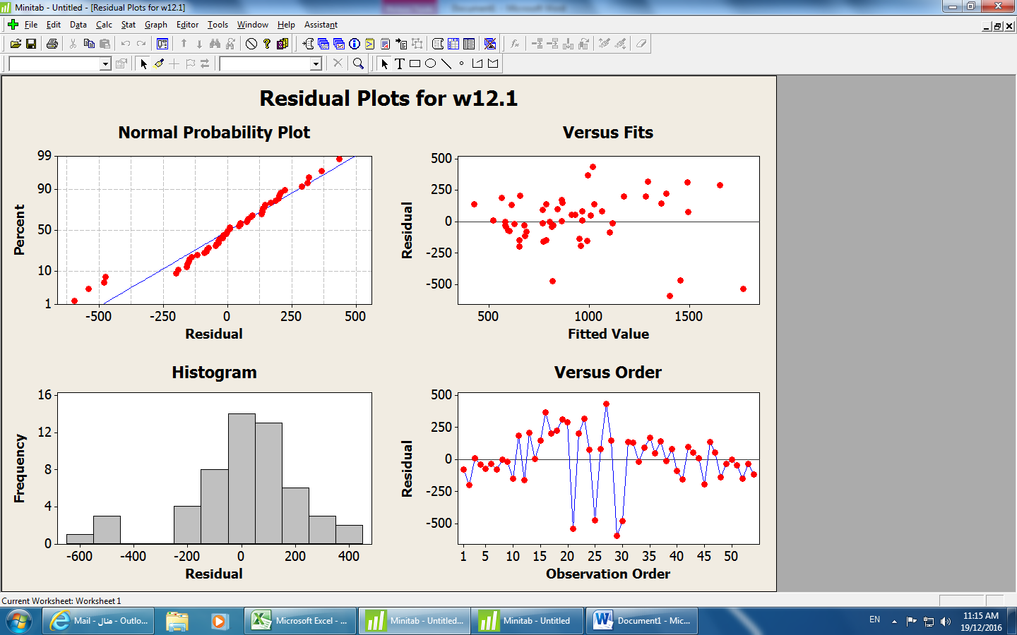

The Fitting Model ARIMA(2,1,0)

ARIMA Model: w12.1

Estimates at each iteration

Iteration SSE Parameters
0 2775711 0.100 0.100 -0.584
1 2447700 0.091 -0.050 -0.851
2 2233896 0.083 -0.200 -0.866
3 2134072 0.076 -0.350 -0.617
4 2126009 0.074 -0.402 -0.341
5 2125961 0.074 -0.406 -0.271
6 2125961 0.074 -0.407 -0.263
7 2125961 0.074 -0.407 -0.263
8 2125961 0.074 -0.407 -0.263

Relative change in each estimate less than 0.0010

Final Estimates of Parameters

Type Coef SE Coef T P
AR 1 0.0745 0.1294 0.58 0.567
AR 2 -0.4068 0.1293 -3.15 0.003
Constant -0.26 28.29 -0.01 0.993

Differencing: 1

The transformation the lemda = 0

So I take the logarithms then the model is to be AR(1)
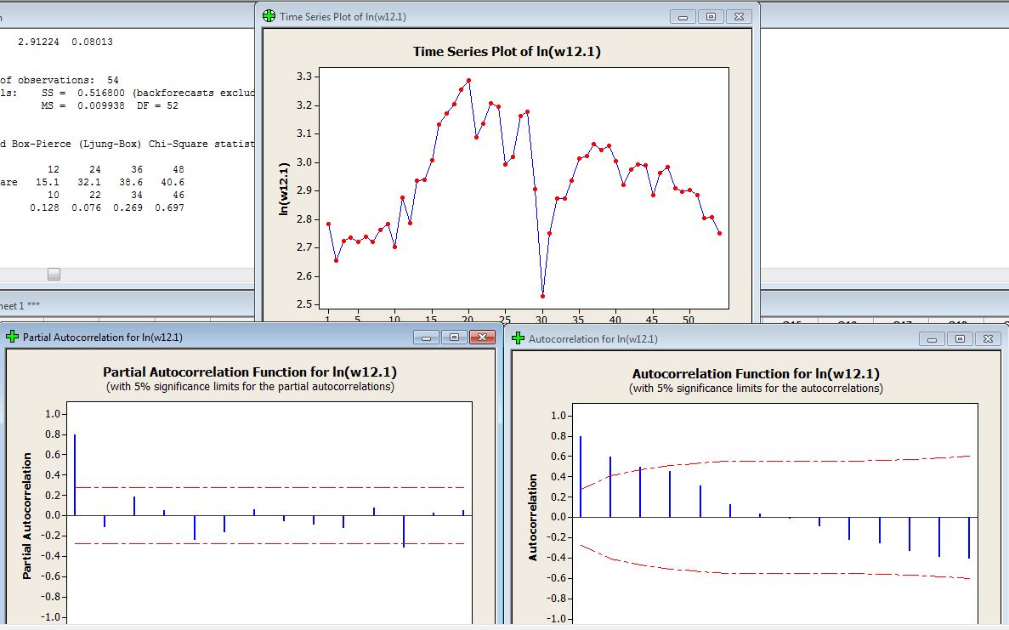

The all P-Value of Modified Box-Pierce ≥ 0.05

The Autocorrelation and the partial Autocorrelation of riesedual equal zero

ARIMA Model: ln(w12.1)

Estimates at each iteration

Iteration SSE Parameters
0 1.74797 0.100 2.734
1 1.29408 0.250 2.274
2 0.94722 0.400 1.813
3 0.70491 0.550 1.354
4 0.56446 0.700 0.896
5 0.52297 0.809 0.563
6 0.52042 0.824 0.514
7 0.52035 0.828 0.502
8 0.52035 0.829 0.499

Relative change in each estimate less than 0.0010

Final Estimates of Parameters

Type Coef SE Coef T P
AR 1 0.8285 0.0810 10.23 0.000
Constant 0.49932 0.01374 36.34 0.000
Mean 2.91224 0.08013

Number of observations: 54
Residuals: SS = 0.516800 (backforecasts excluded)
MS = 0.009938 DF = 52
$$W_{t}=(1-0.8252B)Z_{t}$$

