-5-
Ultrasound examination of the carotid arteries
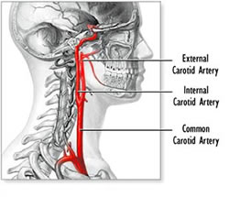
Anatomy:
There are two common carotid arteries (one at each side of the neck):
-the right begin at bifurcation of the brachiocephalic artery.
-the left comes from the arch of the aorta.
Each common carotid artery divided into:
External carotid artery :which supply the exterior of the head ,the face and the greater part of the neck.
Internal carotid artery: which supply the remaining part of the head within the cranial and orbital cavities.
Appearance:
it will appear anechoic with thin echogenic wall.
Probe:
linear (7-10 MHz) probe is used.

View :
- Transverse: thyroids gland with the trachea and the muscle
- Transverse: carotid and jugular vain
- Longitudinal with color and PW to check the velocity of the blood flow , thickness of the wall , and if there is stenosis .

