-4-
Urinary bladder scanning
Anatomy:
A hollow muscular and distensible organ, posterior to the symphysispubis.
Appearance:
If full bladder it will appear anechoic with thin echogenic wall.
Patient preparation:
Full bladder is required.
Probe:
curved (2-5) MHz probe is used.
Breathing technique:
Normal respiration.
View :
- Transverse bladder (black box)
- Longitudinal bladder (measurement the thickness of the bladder wall in the side between the bladder and the uterus –should be not more than 0.5 cm ).
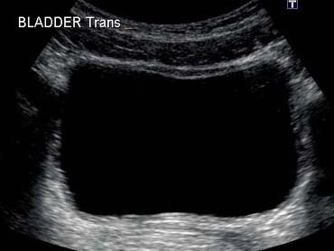
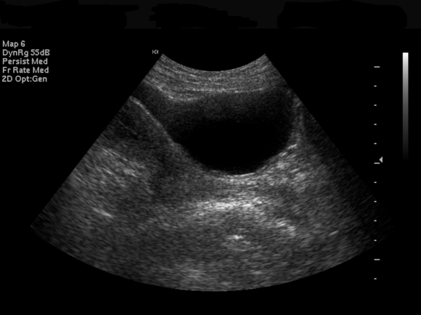
Transverse image showing the Bladder
Longitudinal image showing the bladder

