Gall bladder
Anatomy:
Gallbladder is pear shape sac located in the right upper quadrant (RUQ).It is located inferior to right lobe of the liver.
Part of The gallbladder: fundus, body, and neck.
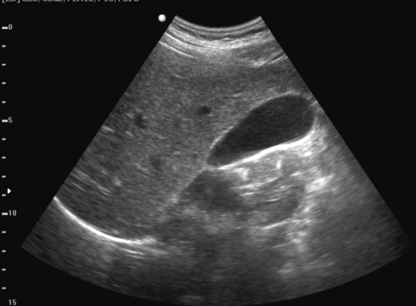
(Neck is stationary part while body and fundus are floating).
Normal variant:
Different shape
Different position
Appearance:
-Anechoic(fluid filled structure)
-Slightly echogenic line of the gallbladder wall. (Thin wall)
Patient preparation:
Patient should be fasting (6-12) hours before the exam because it is contracting and emptying of bile when eating so we can’t see the gallbladder and to reduce the gases.
Probe:
curved (2-5) MHz probe is used.
Breathing technique:
Deep held inspiration.
View :
One image for full G.B .

